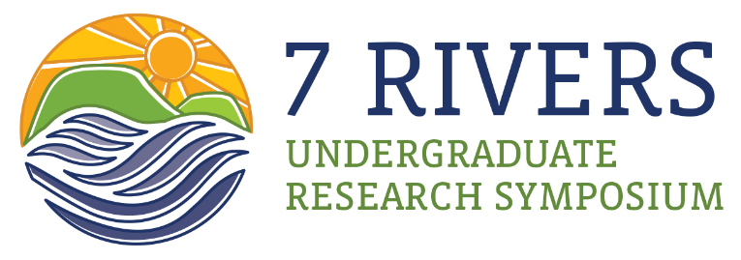

10-11 am Welcome and Keynote Address (Facebook Live) https://www.facebook.com/viterboethics
- Welcome, Dr. Richard Kyte, Director of the D. B. Reinhart Institute for Ethics in Leadership; Jessie Benson, Viterbo University Summer Undergraduate Research Fellow
- Keynote address: Dan Baumgardt, the Science and Operations Officer for the National Weather Service in La Crosse
“The Disturbing Recent Heavy Precipitation Trend across Parts of the Midwest”
- Closing and Symposium Reminders, Richard Kyte, Director of the D. B. Reinhart Institute for Ethics in Leadership
11:15 am- 12:15 pm Oral Presentations – Session 1(RCE 134, RCE 201, BRC 123) - Zoom links e-mailed to presenters and attendees
- Presentations consist of a 10-12 minute talk followed by 3-5 minutes for questions. There will be a short break between presentations.
- Quick References, the Alphabetical Listing of Presenters, Full Abstract Book, and Evaluation Criteria are available online at www.viterbo.edu/sevenrivers.

12:15- 1 pm Break for lunch

1- 2 pm Oral Presentations – Session 2 (RCE 134, RCE 201, BRC 123) - Zoom links e-mailed to presenters and attendees

2:15-3:45pm Poster Sessions (Zoom links e-mailed to presenters and attendees)

Thank you for being a part of the 2020 Seven Rivers Undergraduate Research Symposium. We will be sending out a Survey on your experience including voting within the coming days. Please contact Anouk Goreta at aagoreta@viterbo.edu with any questions or concerns or if you would like to receive schedules for the symposium.

