How to Enter Results in TracDat
Revision date: 10/13/2020
This guide is intended to walk you through the process of entering the results of your unit’s assessment plans.
In the results section of TracDat, enter the results of your assessment methods, create notes about your initial analysis, identify specific actions you will take based on the results, and report on what the follow-up results indicate about those actions. Relate documents to your new results as documentation. You may add any related results from Reporting Units. And, you have the ability to assign a follow-up action to another TracDat user.
To enter assessment results:
- Select your desired unit from the dropdown at the top of the screen.
- Click the ‘Assessment Unit Planning’ tab from the left-hand navigation pane.
- Click the ‘Results’ sub-tab.

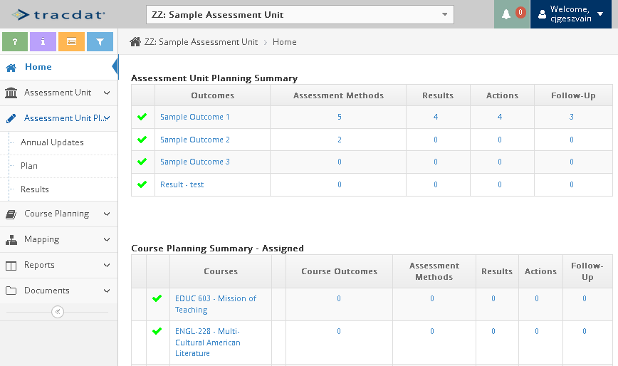
3.

2.

1.

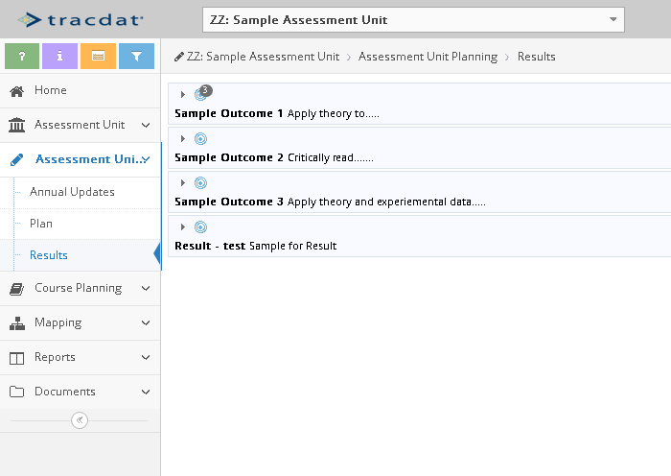

- Expand the Outcome for which you want to enter results by clicking on the gray arrow
for that Outcome. In this example, we have expanded the Sample Outcome 1.

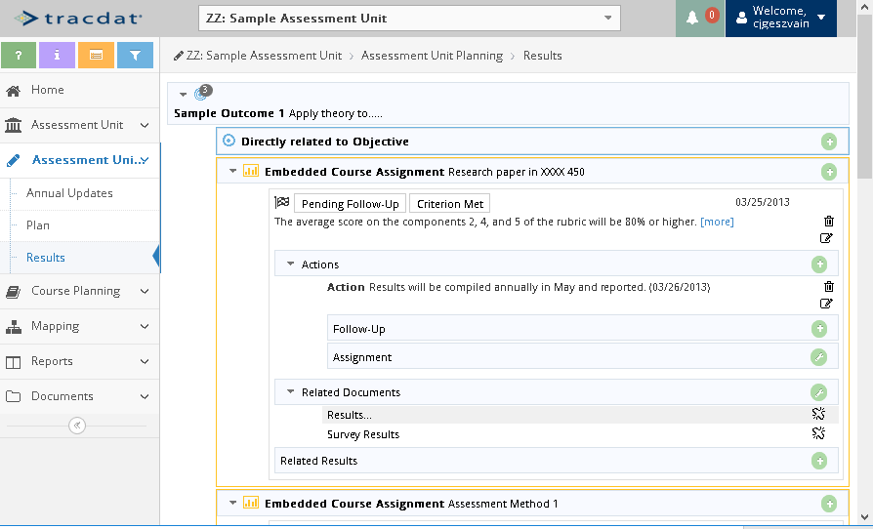
- Locate the appropriate Assessment Method and click the green plus sign icon to Add a Result.
In this example, we will add a result to the assessment method named ‘Embedded Course Assignment Research paper in XXXX 450’, so we will click the green plus sign shown with a red circle in the image above.

- Enter the details of the Result:
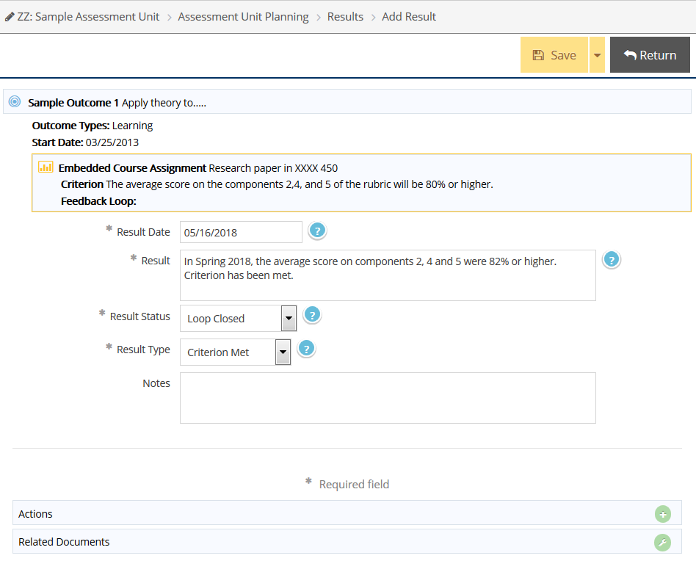

  - Enter a Result Date. Today’s date is entered automatically but can be changed.
  - Describe the Result, giving specific information about the term, the course number, the percentage, and the number included in the percentage, (N=30).
  - Select your Result Status: Loop Closed or Pending Follow-Up
  - Select your Result Type: Criterion Met or Criterion Not Met
  - Make sure you enter information for all required fields, which are indicated with an asterisk.
If your Results have met the criterion:
  - Click ‘Save and Return’ at the top-right side of the screen.

If your Results have not met the criterion, follow these steps to add follow-up action plans.
- Click the green plus sign on the Actions menu (image below).
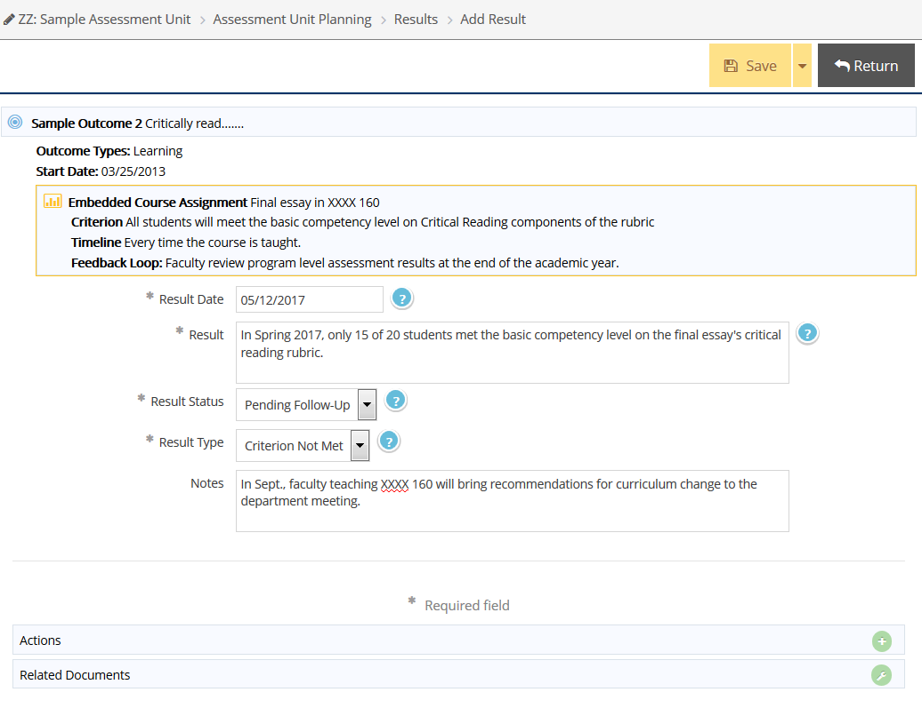
- Enter an Action Date.
- Enter detailed information about the Action, including the specific change, who will make the change, and when the change will be made.
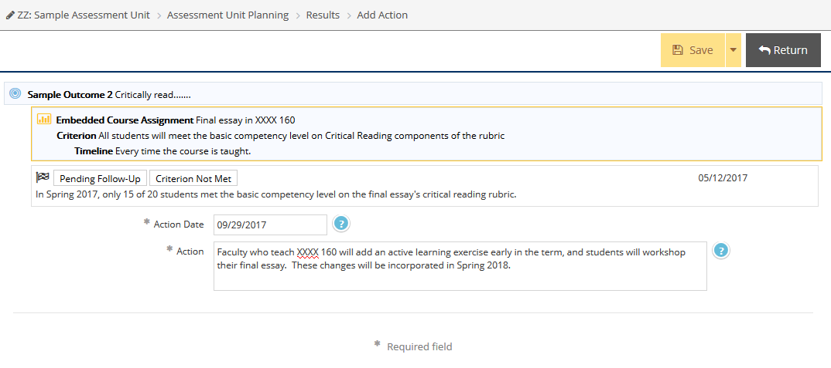
- When finished, click Save and Return to go back to the Results screen.
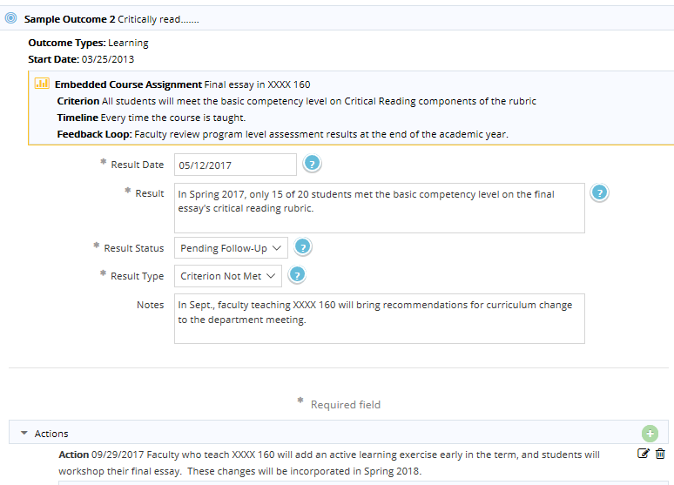
After saving your Action Item, you are returned to the Result screen.
Be sure to click Save and Return again to save the Result.

After you have made the changes, follow up by collecting results and evaluating them. Then, add the new results.
- Go back into the Action Item area and click on Follow-up.
- In Follow-Up, briefly describe the impact of the action, referring to the new results.
- Click Save and Return to save the Follow-Up information.
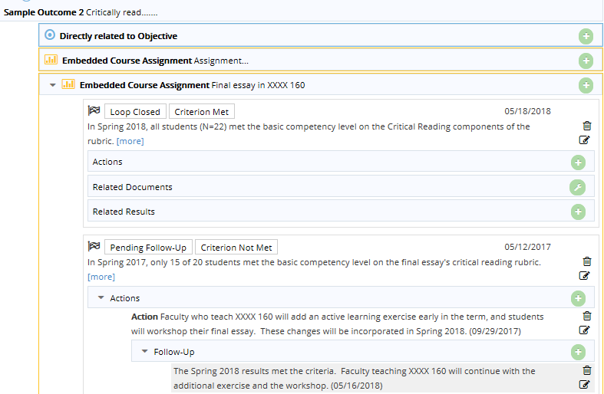

If questions on TracDat, contact the Assessment & Institutional Research department:
Carol Geszvain, Ext. 3485, cjgeszvain@viterbo.edu
Derek Klein, Ext. 3486, dpklein@viterbo.edu
Naomi Stennes-Spidahl, Ext. 3481, nrstennesspidahl@viterbo.edu

