Virbatim User Guide
  - Principal Investigator
Virbatim is a system at Viterbo that the Institutional Review Board (IRB) Committee uses to track human subjects research. All students and faculty engaged in human subjects research must have their research protocol approved using this system. For more information on IRB, visit http://www.viterbo.edu/irb.

Creating an Account
Users with a Viterbo email account can create a login using the steps below.
Students taking these types of classes do not have Viterbo Email access as part of their account:
- Those considered “Professional Development” (i.e. Blue Brochure).
- Those obtaining their Masters of Arts in Education.
- Those obtaining their 316-Reading License in a non-financial aid based location.

If you are in one of these programs or you don’t have a Viterbo email for any reason, you need to email irb@viterbo.edu and you will be sent an invitation to complete the setup of your IRB account using your personal email address.

- Visit http://app.virbatim.com/register.aspx?institutionid=1051.
- Complete all the required fields. You must use a Viterbo email to login unless you’ve received an invitation as explained above.
- You will receive confirmation link via email, which you must click on to activate your account.

Logging In
- Visit http://app.virbatim.com/
- Log in with your full email address in the username field, and the password you selected when registering.

System Navigation
Users will encounter the following screen when they log in.
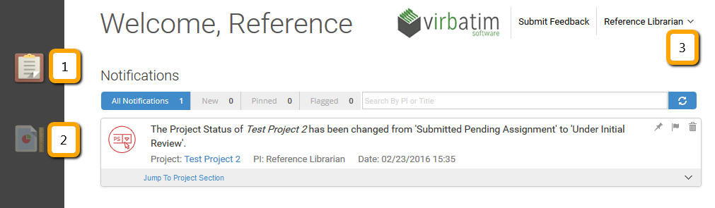
- This icon represents the notification pane. Notifications inform users of the current status of their projects. Notifications can be viewed, pinned, and archived from this screen.
- This icon represents submitted projects. More information on projects is on the next page.
- To log out or get to your user profile, including changing your password, click on the arrow next to your name.

Submitting a Project
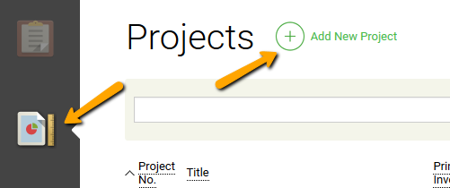
- To create a project, click on the project icon on the left on the screen, and click Add New Project.
- In the General Info screen, enter the project title, brief description, and expected review type. For more information on review types, visit the IRB webpage listed on the previous page.
- Users must list themselves as Principal Investigator, but may add co-investigators. If a co-investigator is not found through the text-entry box, users may add them by selecting Create New.
- Select Save and Next.

Note: Co-Investigators added by Principal Investigators do not automatically have logins to the system. Anyone needing to access Virbatim should go through the account creation listed on the first page of this document.
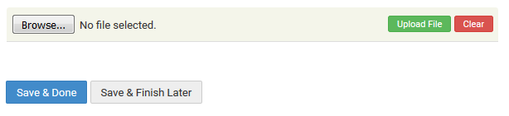
- In the Complete Application section, users must fill out all required fields with information about the project. Fields with a red star are required.
- In the Supporting Documentation section, users must upload any required supporting documentation. Information on required documents are available on the IRB website and in the text box at the top of the screen.
- Most major document and image file types are accepted. Documents must be added one at a time, but multiple documents can be added to a project.
- Users may select Save & Done once they are complete, or Save & Finish Later if needed.

Managing Projects
Communication with the IRB committee is integrated into the project section of Virbatim. After selecting the project name, users can view the following areas by clicking on the left-hand project menu:
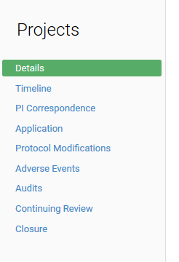
- Details – Information about the project, important dates, and current status.
- Timeline – A chronology of IRB-related project events.
- PI Correspondence – Communication between the Reviewer(s) and the Principal Investigator.
- Application – Full-text of the application and submitted forms. Additional documents or revisions may be added as requested by the IRB committee.
- Protocol Modifications – If modification of the research protocol is needed after approval, users may submit requests in this section.
- Adverse Events – If an adverse event occurs, users must report them through this section.
- Audits – If an audit is conducted, documentation must be reported through this section.
- Continuing Review – If a principal investigator wishes to continue their research project after the one-year period, they must submit a request for continuation through this section.
- Closure – Reports confirming the end of a project are submitted through this section.

Project Communication
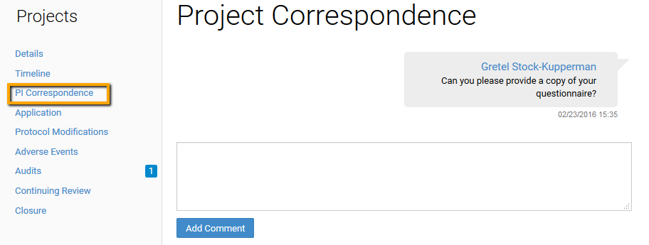
When reviewers have questions or need additional information for a Principal Investigator, those comments are captured in the PI Correspondence section of Virbatim. Questions and responses show up in a chat-like interface.

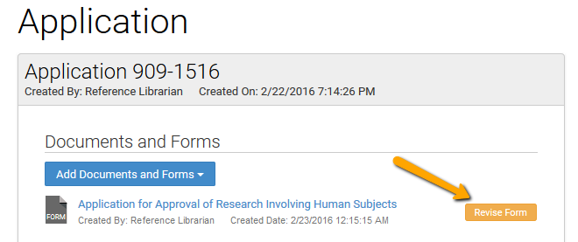
If changes to documents are needed, the Principal Investigator must choose Revise Form from the Application section of the project. Additional documents or a revised application may be submitted. The old application will remain in Virbatim for audit purposes.

