Viterbo University
Online Payroll Advices
Procedure Guide

The Online Payroll Advice workflow allows you to view direct deposit payroll advices online anytime and anywhere seven days a week. Payroll advices issued after December, 2005 are available online. To enter Online Payroll Advices, select Microsoft Internet Explorer, type http://webadvisor.viterbo.edu in the address line and click on go.

Click on LOG IN

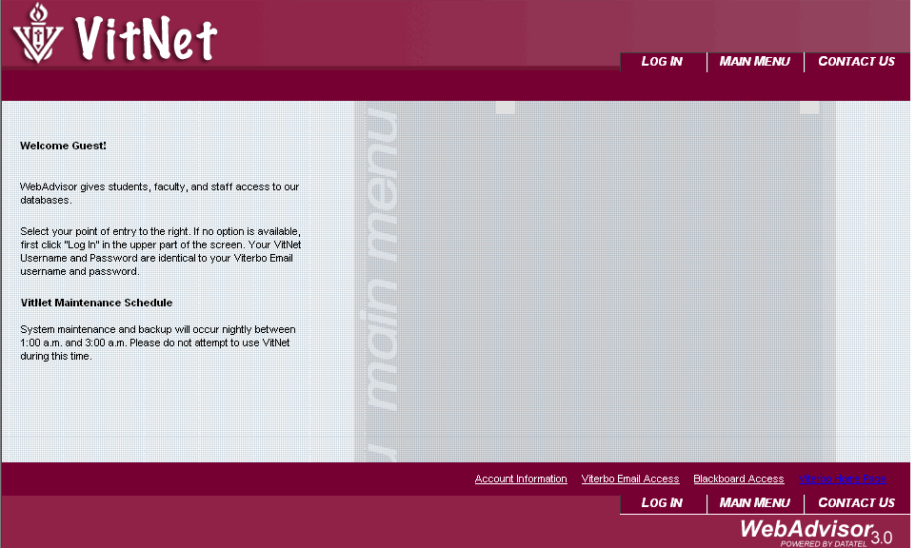

Enter your name that is used in your Viterbo email address and then enter your password. Your password generally is the same as your email password unless you change it. Click on submit and you will be taken to the Vitnet Menu window.

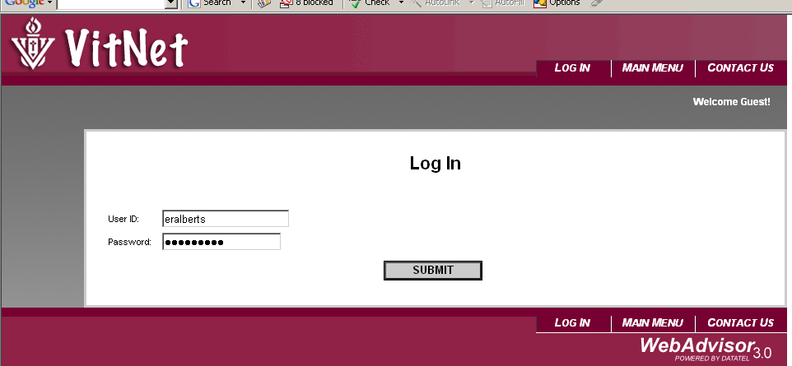

Click on the Employee tab.

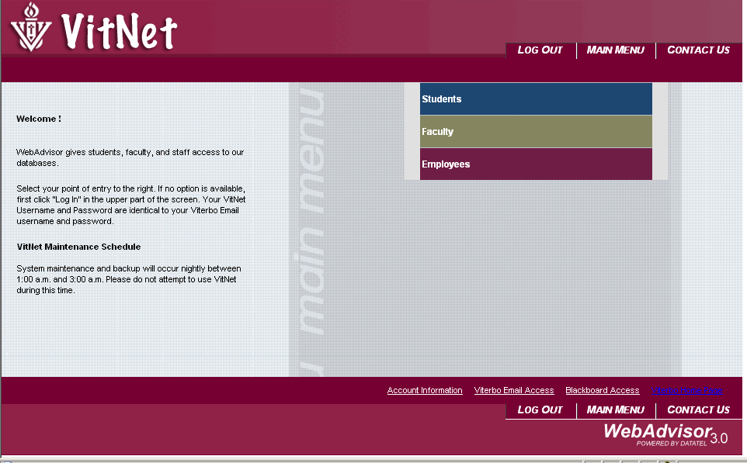

Click on Pay Advices

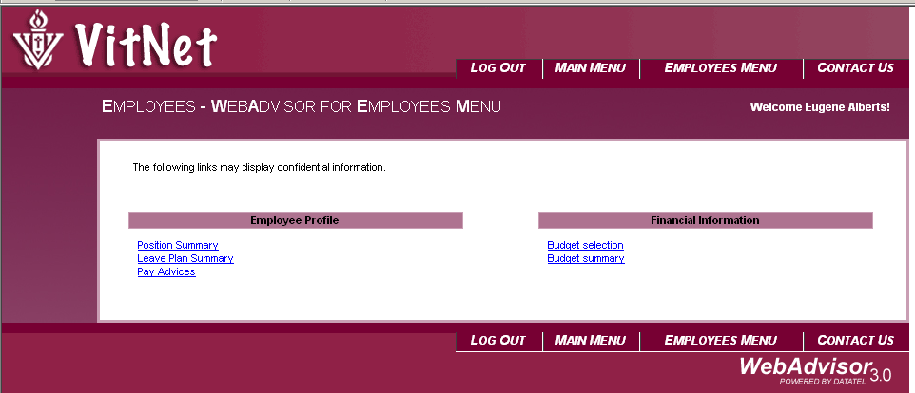

Click on the pay advice you wish to review. If you would like to review an advice from a prior year, choose a year using the down arrow and click on submit. A list of available advices from that year will be shown. Click on the advice you wish to view.

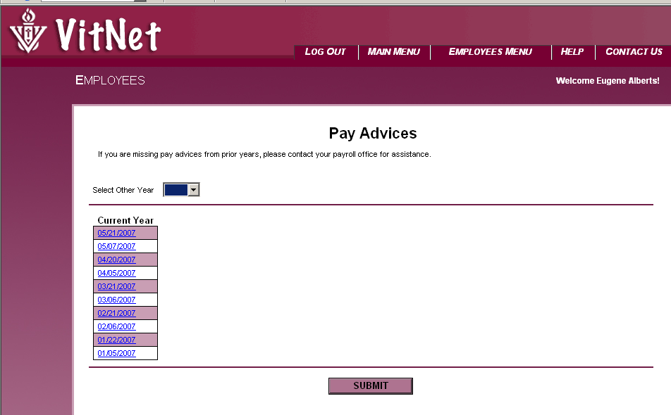

One you select an advice, the actual advice will appear.

You may print the advice, however since they are always available online; it is recommended that you do not print the advice out. If you choose to print the advice, then click on File and then Print. The window below will appear.

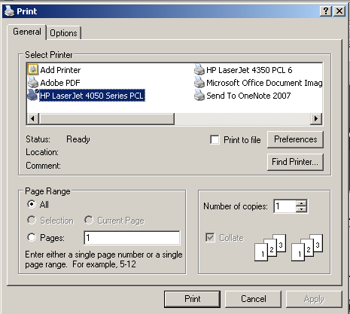
Click Here

Select Preferences
Choose Portrait
Choose Portrait
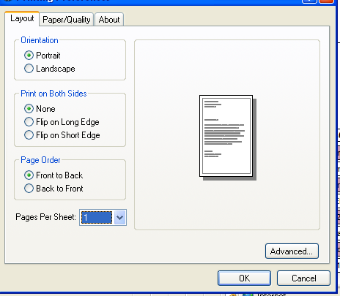

Click on OK and then Print.

When you are finished viewing the Advice. Click on OK at the bottom of the screen.

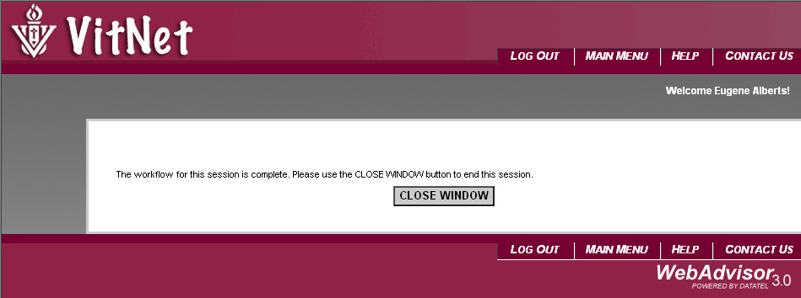

Then click on the close window.

You will return to the Pay Advices screen.

Log out of Web Advisor and close your browser.

