Viterbo University
My Budget
Procedure Guide

The My Budget workflow allows you to view budget information about any of the general ledger accounts for which you are responsible. To enter My Budget, select Microsoft Internet Explorer, type http://webadvisor.viterbo.edu in the address line and click on go.

Click on LOG IN

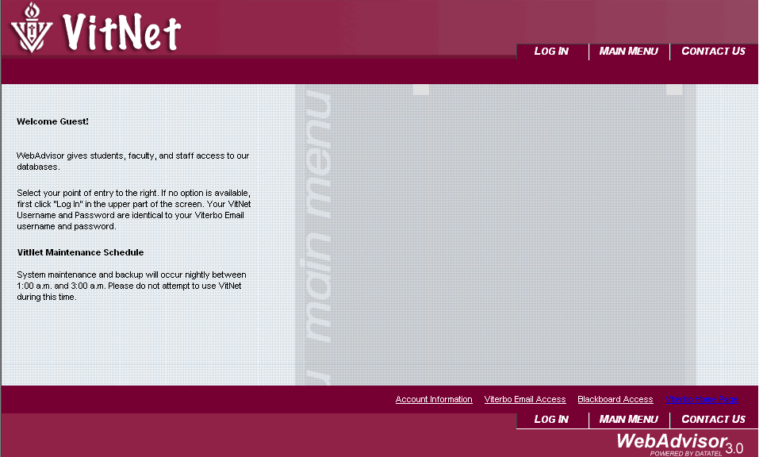

Enter your name that is used in your Viterbo email address and then enter your password. Your password generally is the same as your email password unless you change it. Click on submit and you will be taken to the Vitnet Menu window.

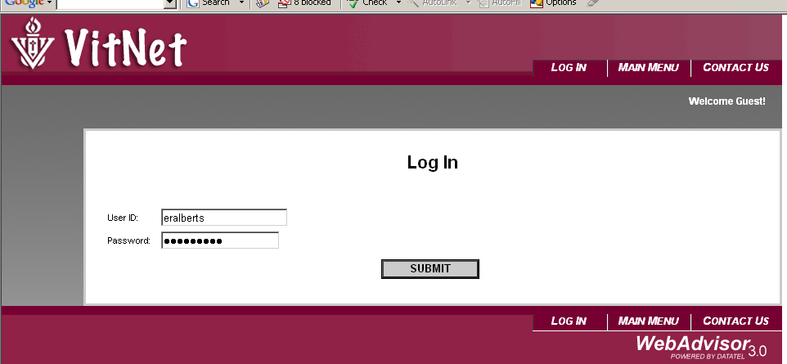

Click on Employee or Faculty, depending on your position.
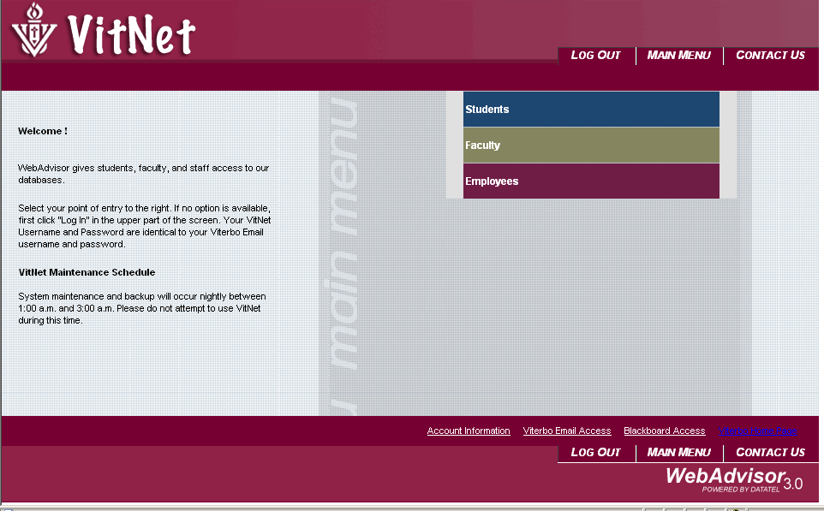

Click on budget selection. You will be taken to a log in window.

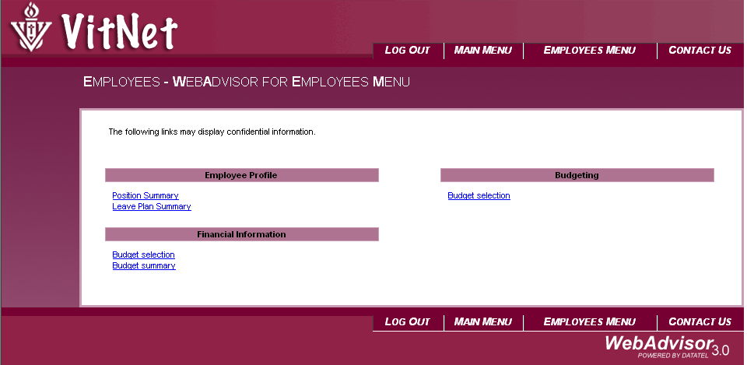

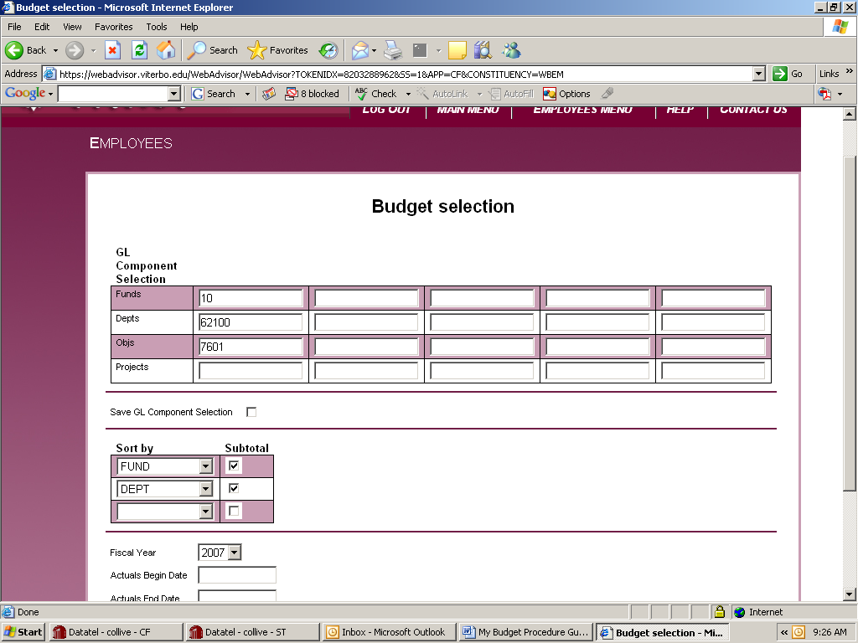
Enter the whole number or just the first couple of digits to restrict departments or objects.
Choose Fiscal Year

Use the My Budget Selection form to choose the GL accounts you want to view, and to enter your sort criteria. When you click the Submit button, the Budget Selection form displays budget information for the accounts you have selected.
To see all of your accounts, leave all of the GL Account Selection fields blank. Note that if you are responsible for a large number of accounts, the selection process might take so long that the system "times you out." If you receive a warning that the "requested web page is inaccessible," you can log back into the system and enter selection criteria to limit the number of accounts that appear.
You can enter selection criteria against any of the GL account components used at your institution. Enter the value of the components, or any of its subcomponents, to select the desired accounts that will appear on your inquiry.
You can enter up to five choices for each account component.
After entering selection criteria, you can specify the way you want the accounts to be sorted on the Budget Selection form. The form displays accounts in ascending order based on the sort options you select, and will break and subtotal on each of the first two sort fields you specify. If you enter one sort field, you get only one break.
A report will appear with the accounts you have requested.
For additional information on an account, simply double click on the number. A report will then appear.
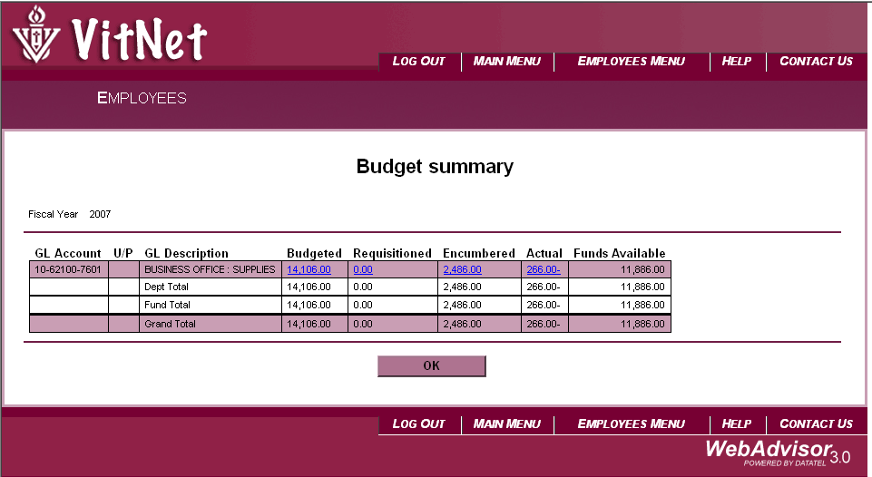
Click on any number to detail year to date activity
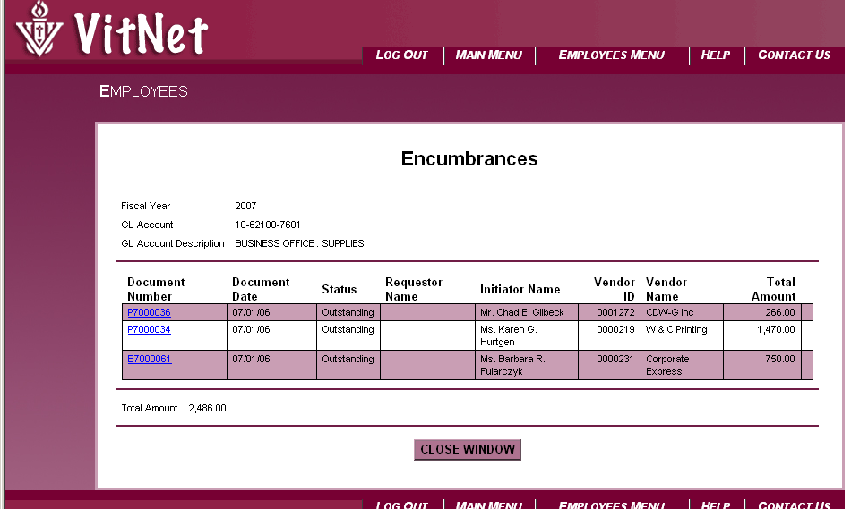
Note that you can detail down on only one account at a time.

You may click on the Close Window button or the Back button to return to the previous screen.

Printing
You may print reports with using Vitnet. Select File and the Print on the menu bar.

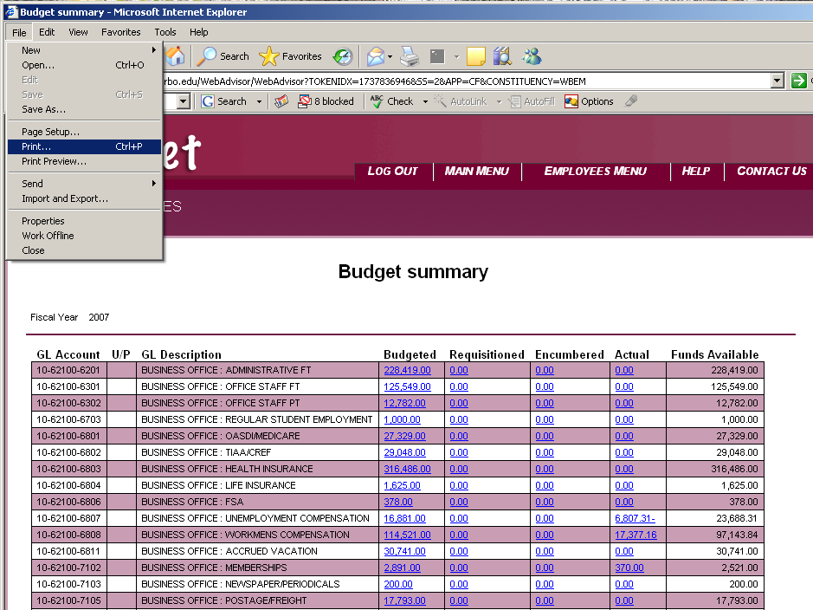
Select Preferences
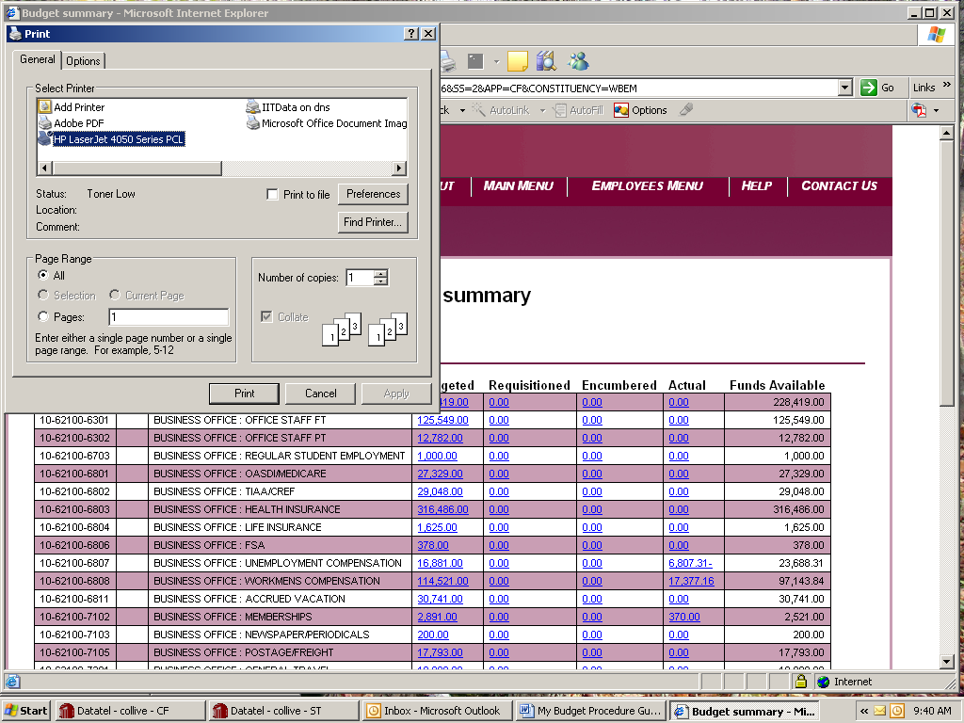
Select Landscape and one per page.
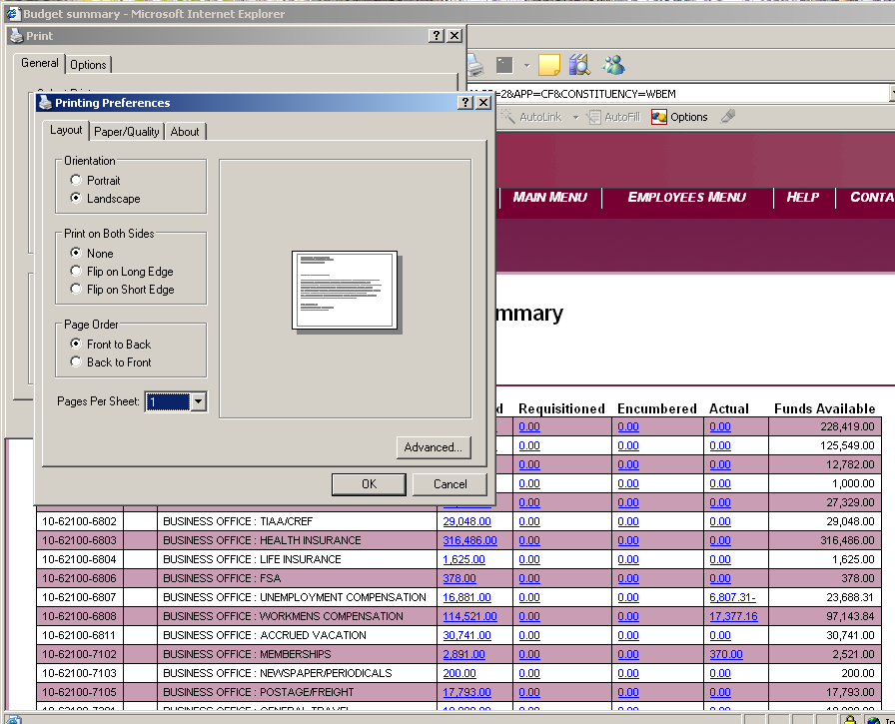

Click on OK and then on print.
When complete, Log Out.
If you find that you do not have access to a particular account that you have oversight of, please send an email to eralberts@viterbo.edu specifying which accounts need to be added.
Please note that the appearance of WEBADVISOR will change as other DATATEL workflows come on line.
Please be aware that the system will log you out after 30 minutes of inactivity.

