PROCEDURES FOR ORDERING OFFICE SUPPLIES ON LINE THROUGH CORPORATE EXPRESS E-WAY

- Prepare a Viterbo University Purchase Order consistent with Viterbo University purchasing policy, completing the form and obtaining authorization signatures as appropriate.
- Submit completed, authorized Purchase Order to the Business Office.
- The Business Office will verify account balance availability, assign a Purchase Order Number, and return the Purchase Order to the initiator.
- Access E-Way at www.eway.com.

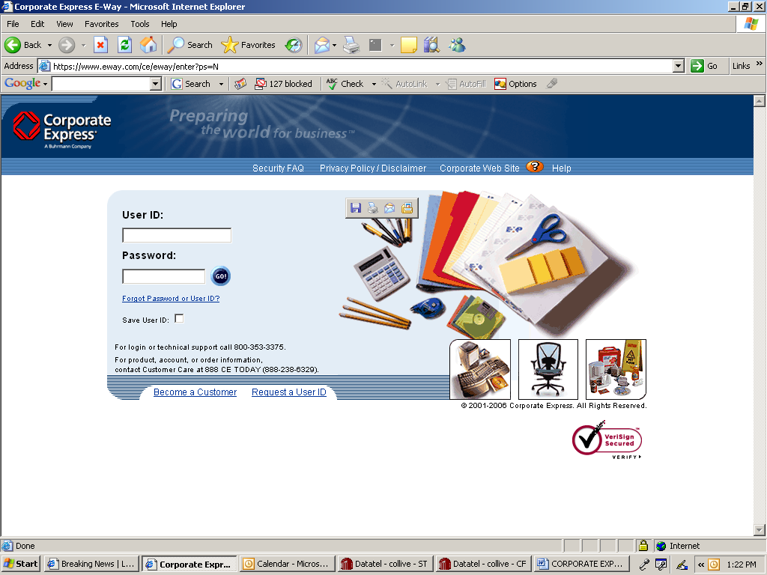
Click “GO!”

- Enter unique login information. You will enter your User ID and password, which will be provided via email by Corporate Express once your account has been established, and click “GO!”.

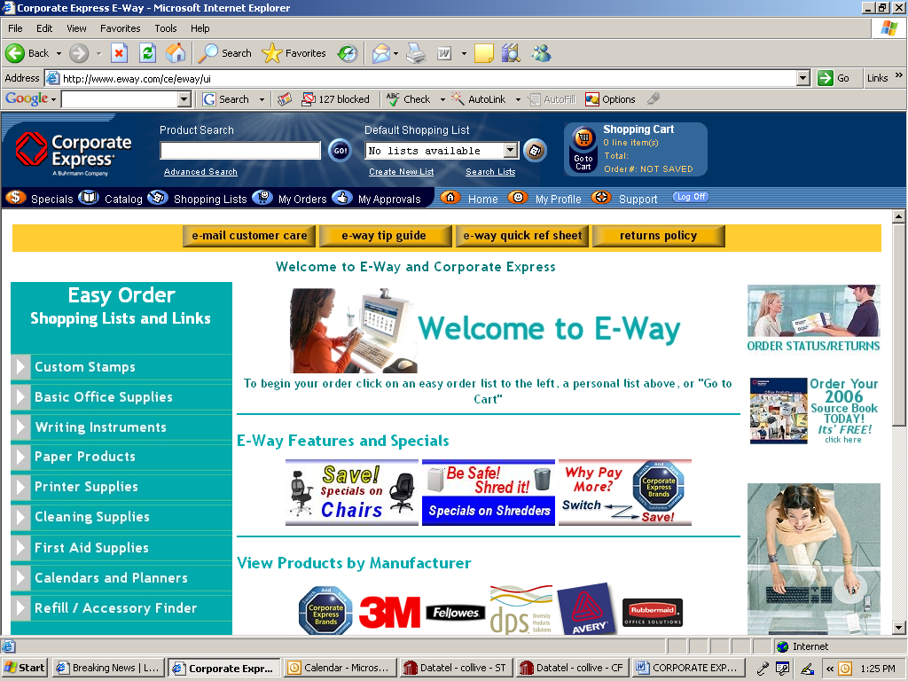

- Shop for the items listed on your Purchase Order, adding them to your “Shopping Cart”. You may use any of the Corporate Express search features (e.g. “Easy Order Shopping List and Links”, “Product Search”, “Go to Cart”, etc.) to shop for your items.

Click on “Go to Cart” to begin the process of checking out.

- When all items have been added to your “shopping cart”, click on “Go to Cart” to begin the process of checking out.

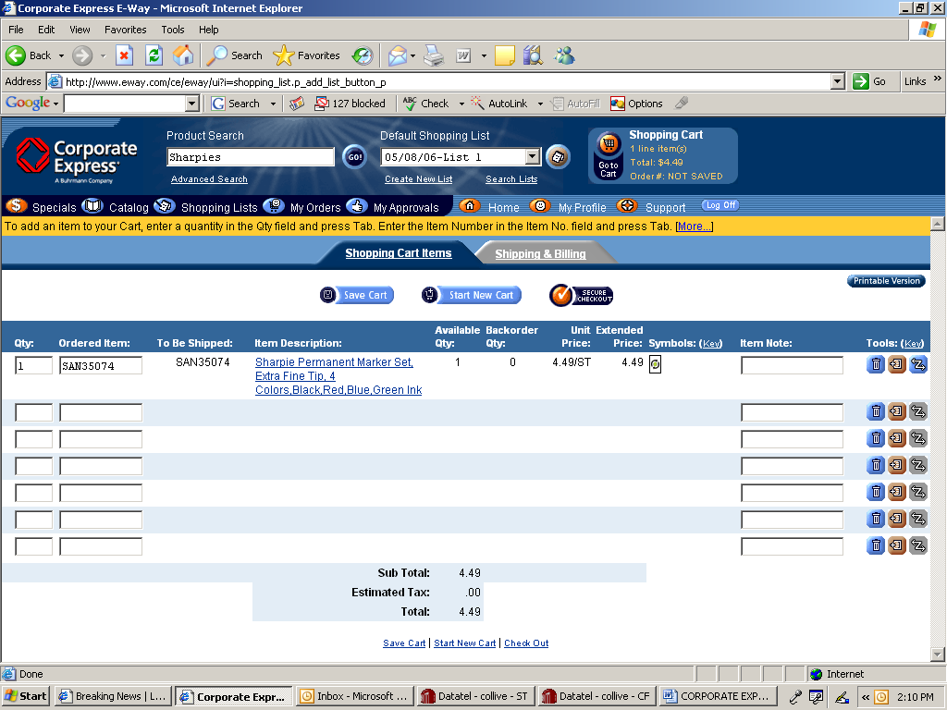
Click on “Shipping & Billing” to provide shipping information and enter Purchase Order Number.

- When you have confirmed the order items, click on “Shipping and Billing” to provide shipping information and enter the Purchase Order Number.

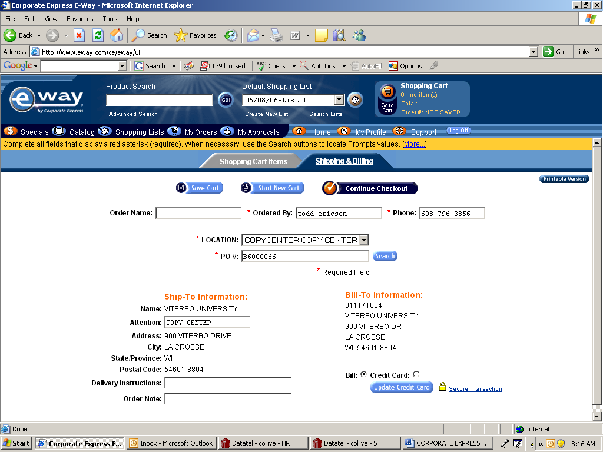
Enter approved VU Purchase Order Number.
Click on “Continue Checkout”.
Verify Name.
Verify Phone.
Verify Location as “Copy Center”.
You may enter your Department Name here.

- Verify order information, including “Ordered By”, “Phone”, and “Location”, and enter the Purchase Order Number. You may enter your department name in the “Order Notes”. You must enter the Purchase Order Number. Click on “Continue Checkout”.

Click on “Secure Checkout”.

- Click on “Secure Checkout”.

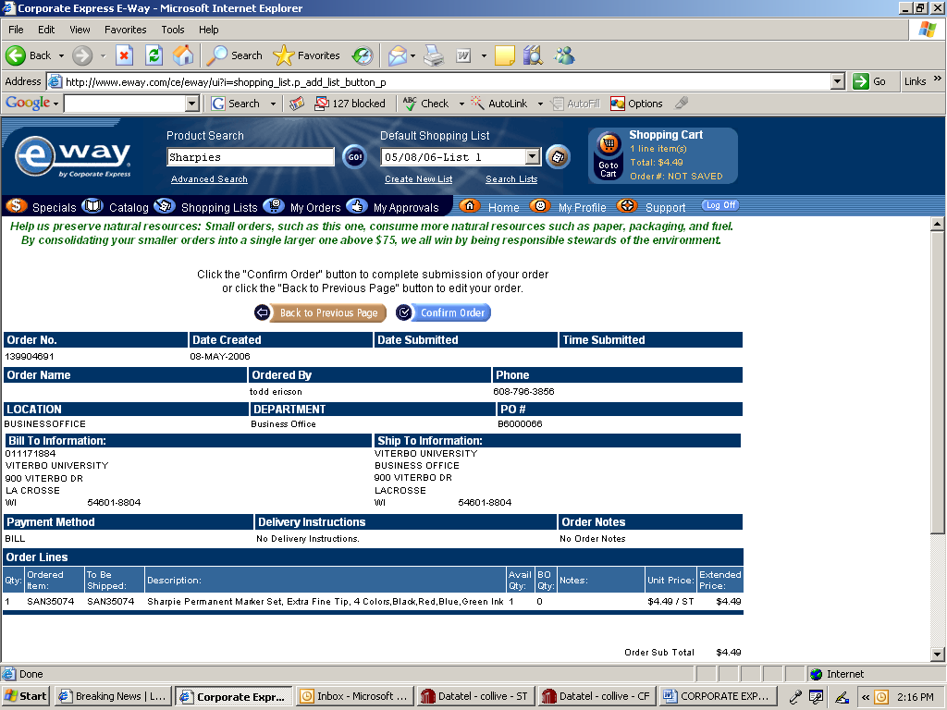
Click on “Confirm Order”.

- Review your order information for accuracy. Click on “Confirm Order” to confirm your order.

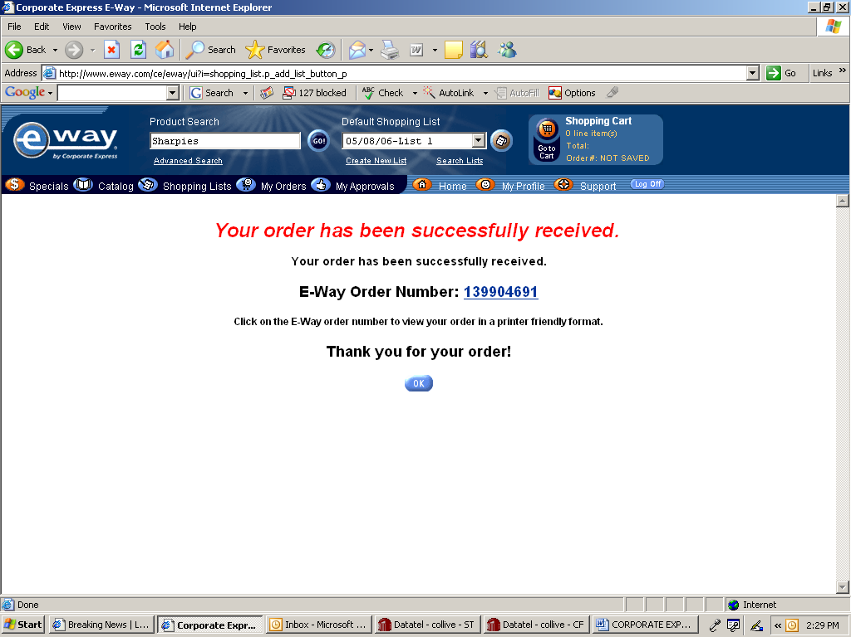

- You will be notified that your order has been placed. You will also receive an email confirmation of your order. If the order exceeds your specific user maximum order level, as established by the Business Office, you will be notified that your order was submitted to your administrator for review. The Business Office would then access E-Way to review the order and approve it.
- Corporate Express will deliver your order to the Copy Center/Mail Room, and you will be notified of its arrival.
- Corporate Express will invoice the Business Office periodically for any purchases.

