Viterbo University
Self Service Budget Procedure Guide
Procedure Guide

The Self Service Budget workflow allows you to view budget information about any of the general ledger accounts for which you are responsible for the past five fiscal years. To enter Self Service Budget, log into Vitnet and select Employee.

Under Employee click on Budget under the Self Service heading

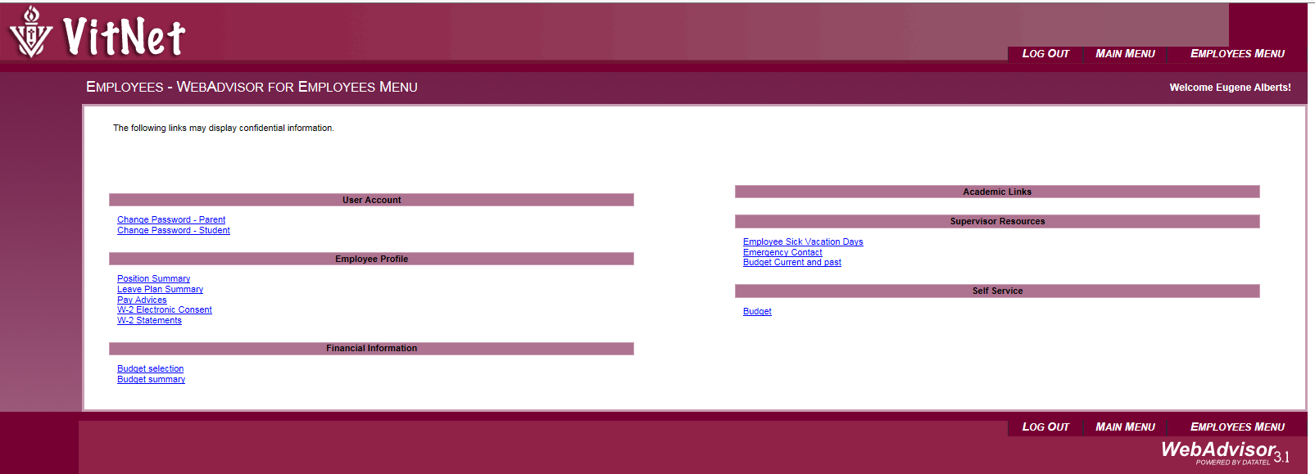

Click on Budget

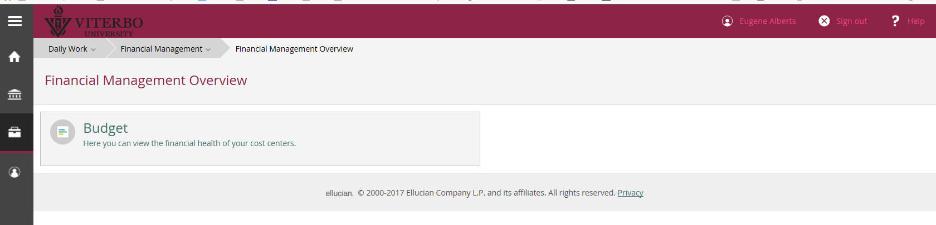

All of your Cost Centers “Departments” will load. You can view your cost centers by either Graphs or List by selecting either icon.
Select Graph or List

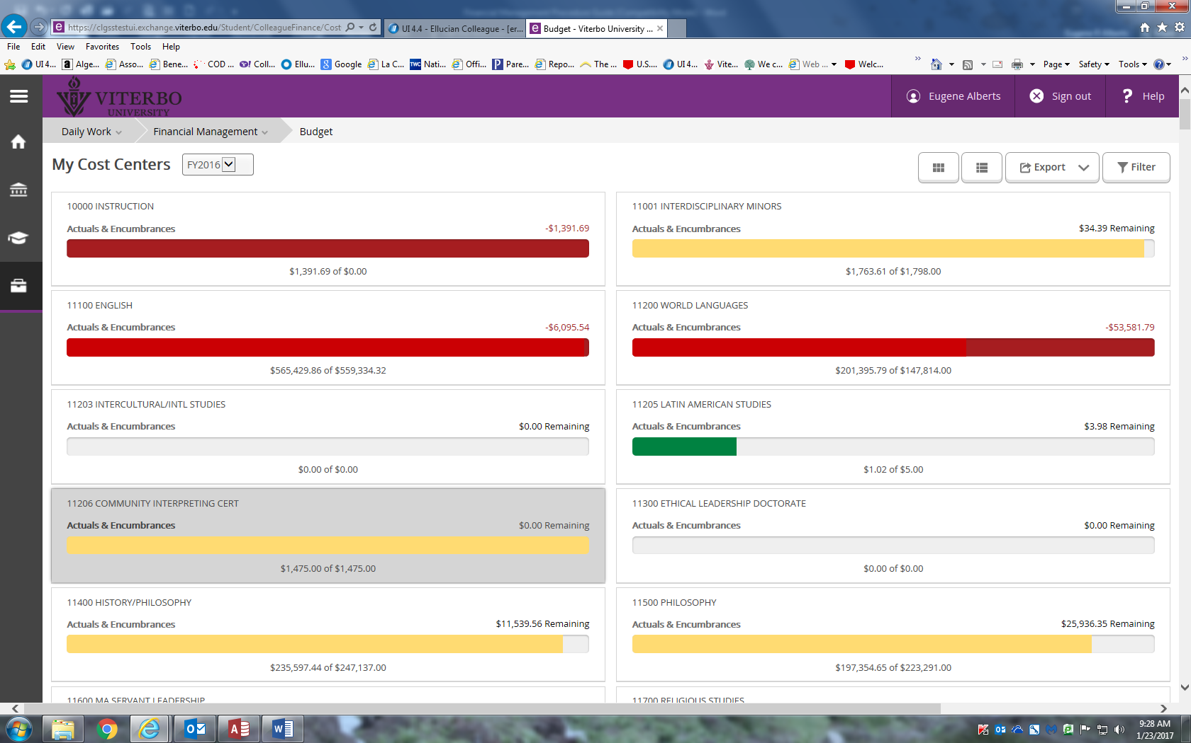

You now have access to the current fiscal year plus the previous five years.

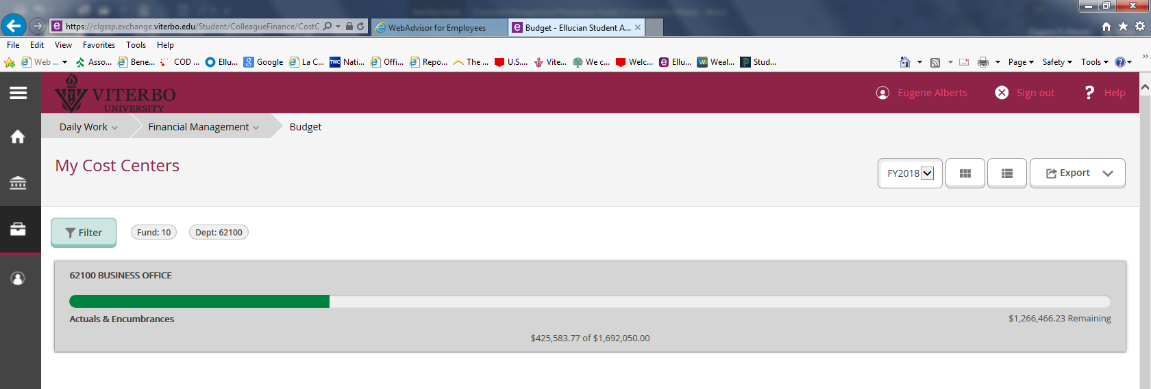
Choose Fiscal Year

Filtering
If you choose to limit your selection, you may do this by filtering your cost centers. Click on Filter and choose one of the drop down arrows, Fund, Dept or Obj. Enter the criteria you wish to filter. Click on Apply Filter

Fund – First 2 digits (10, 26, 72, 73, 76, 78)
Dept – Next – 5 digits (62100, ect…)
Obj - Last 4 Digits (7001…7809)

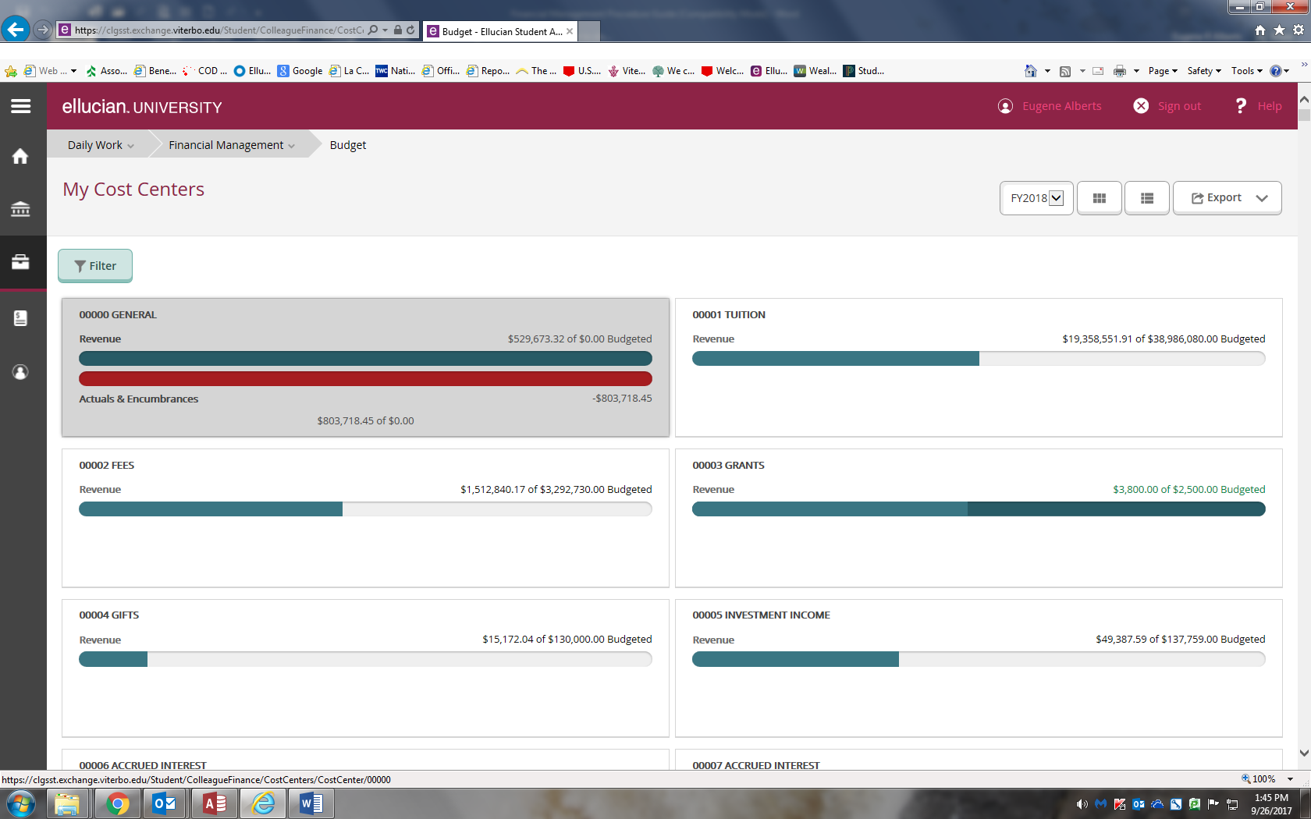
Filter

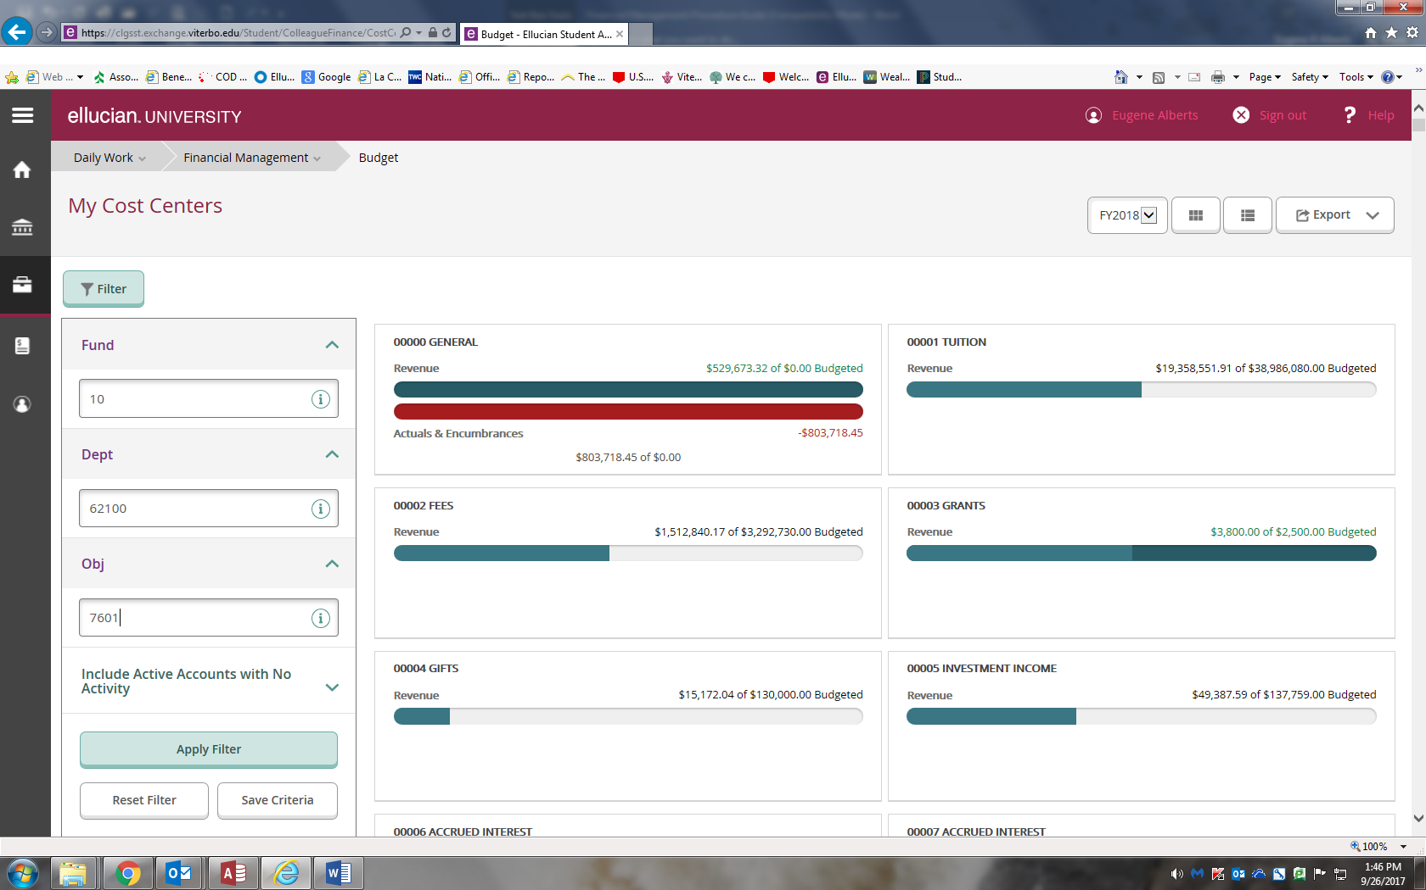
After clicking on Apply Filter you will get your selection only.
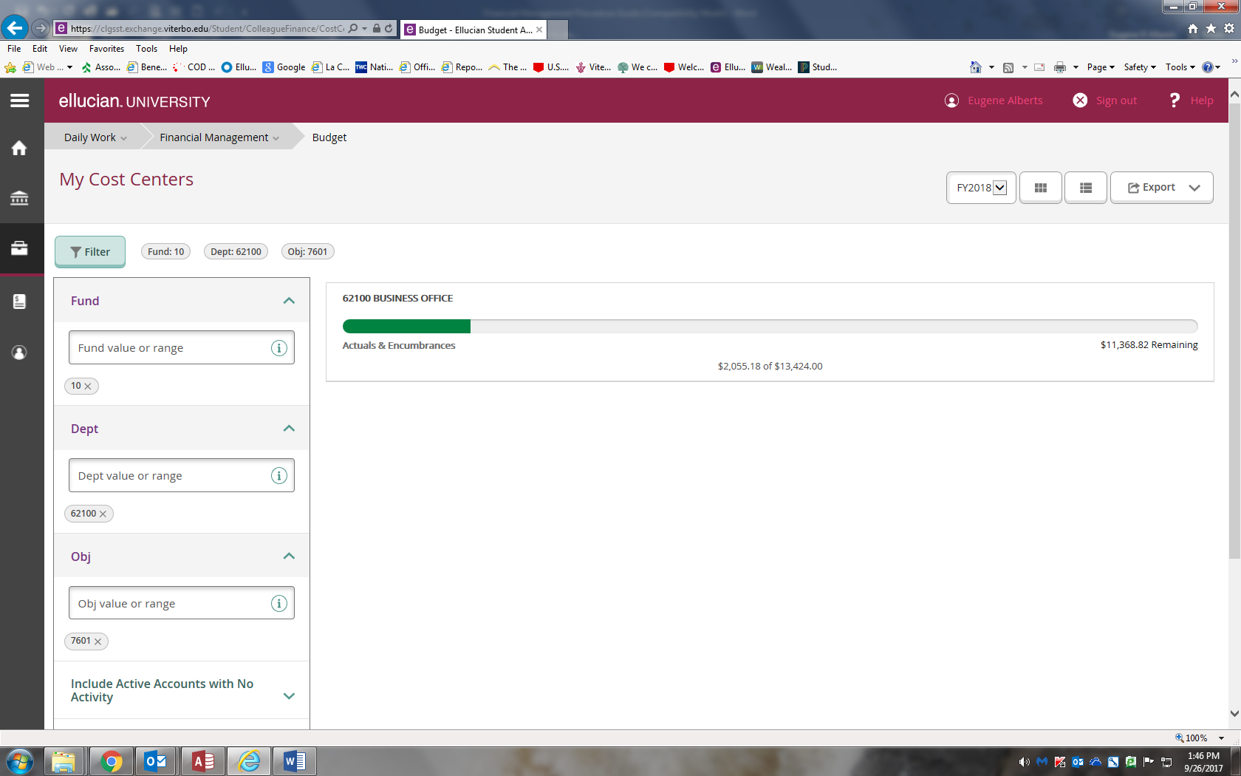

The filter criteria will remain until you remove it. You can now save the filter by naming it. You may also set any filter named as your default criteria. The default criteria is the view you will see each time you enter Self Service Budget.

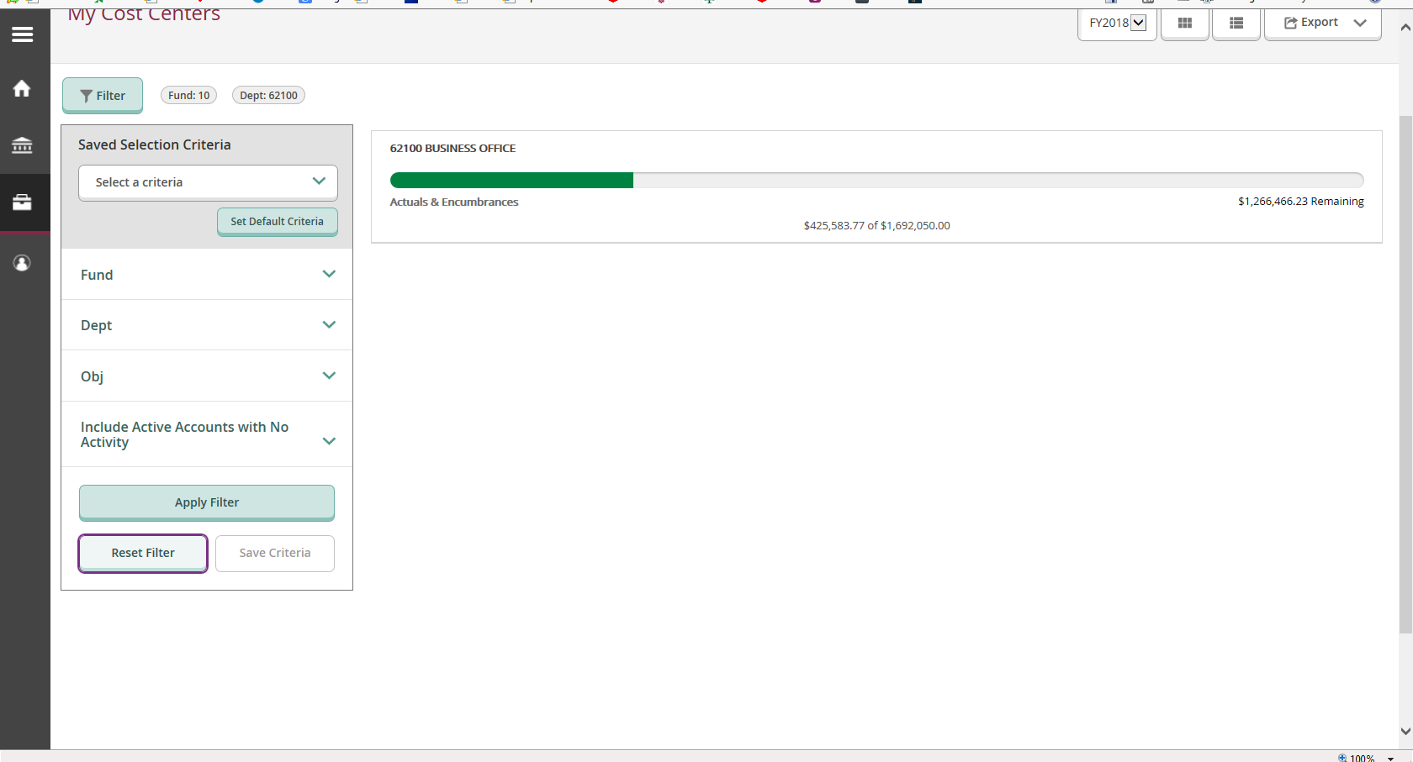
Save criteria or reset the filter here
Set Default Criteria here
To see additional detail on the Department or Account, simply click on it.

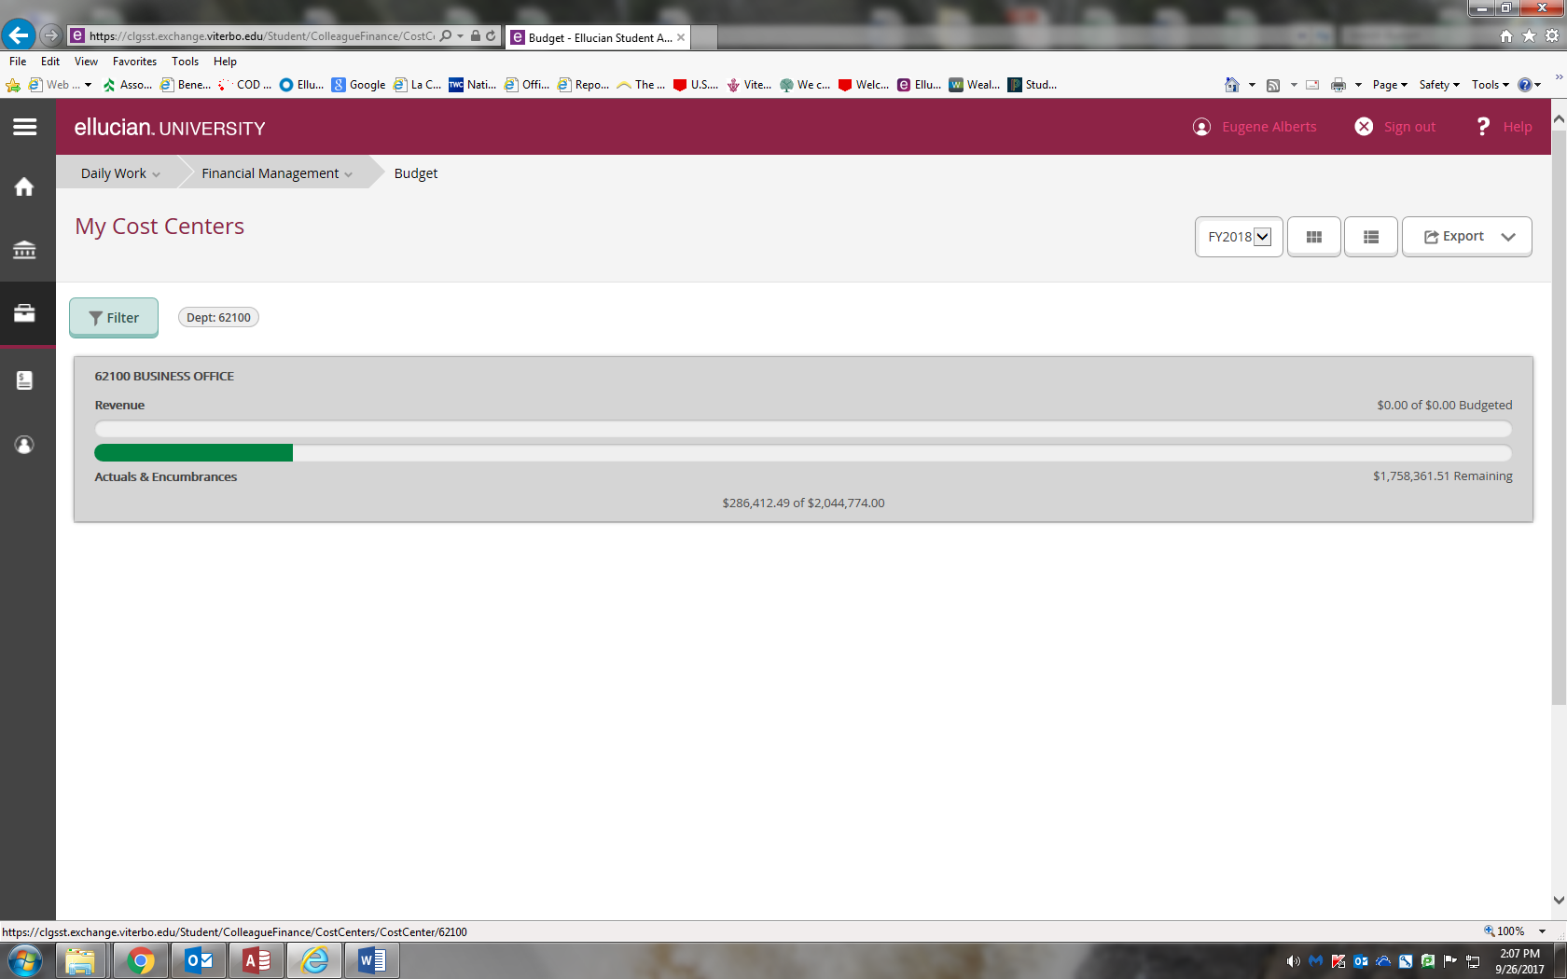
Click here

Selct a drop down arrow next to the categaory you wish to view

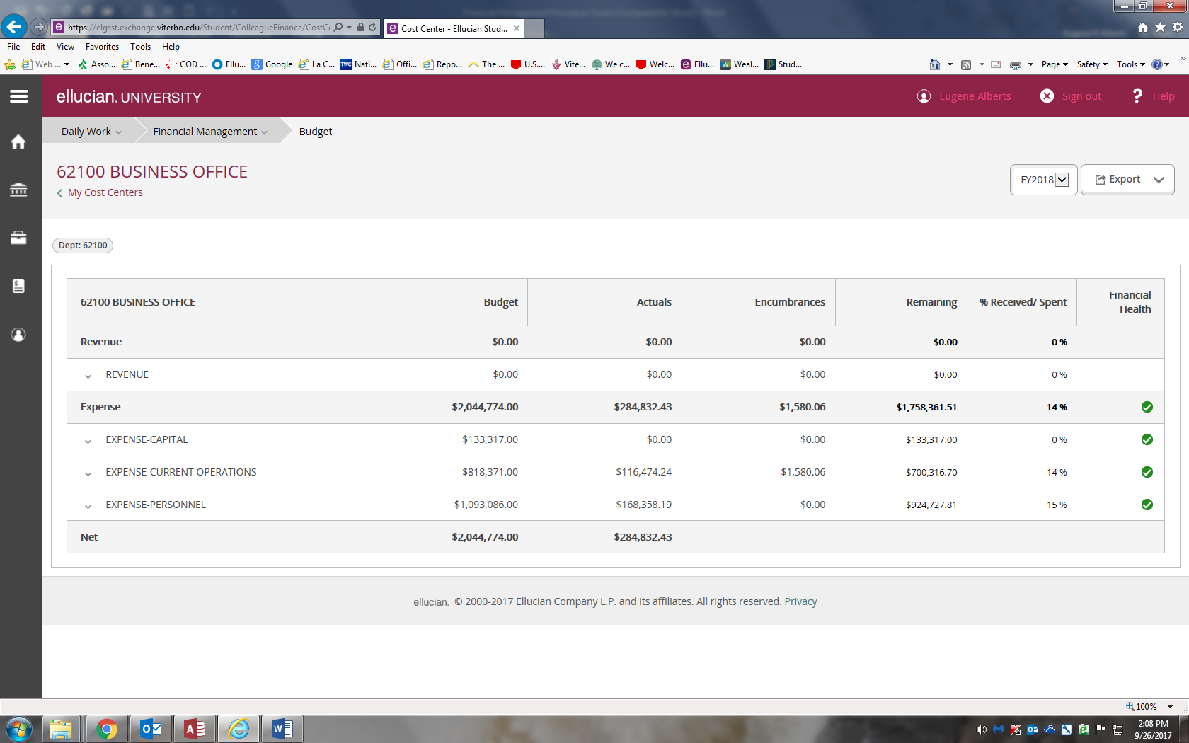

Click on the account

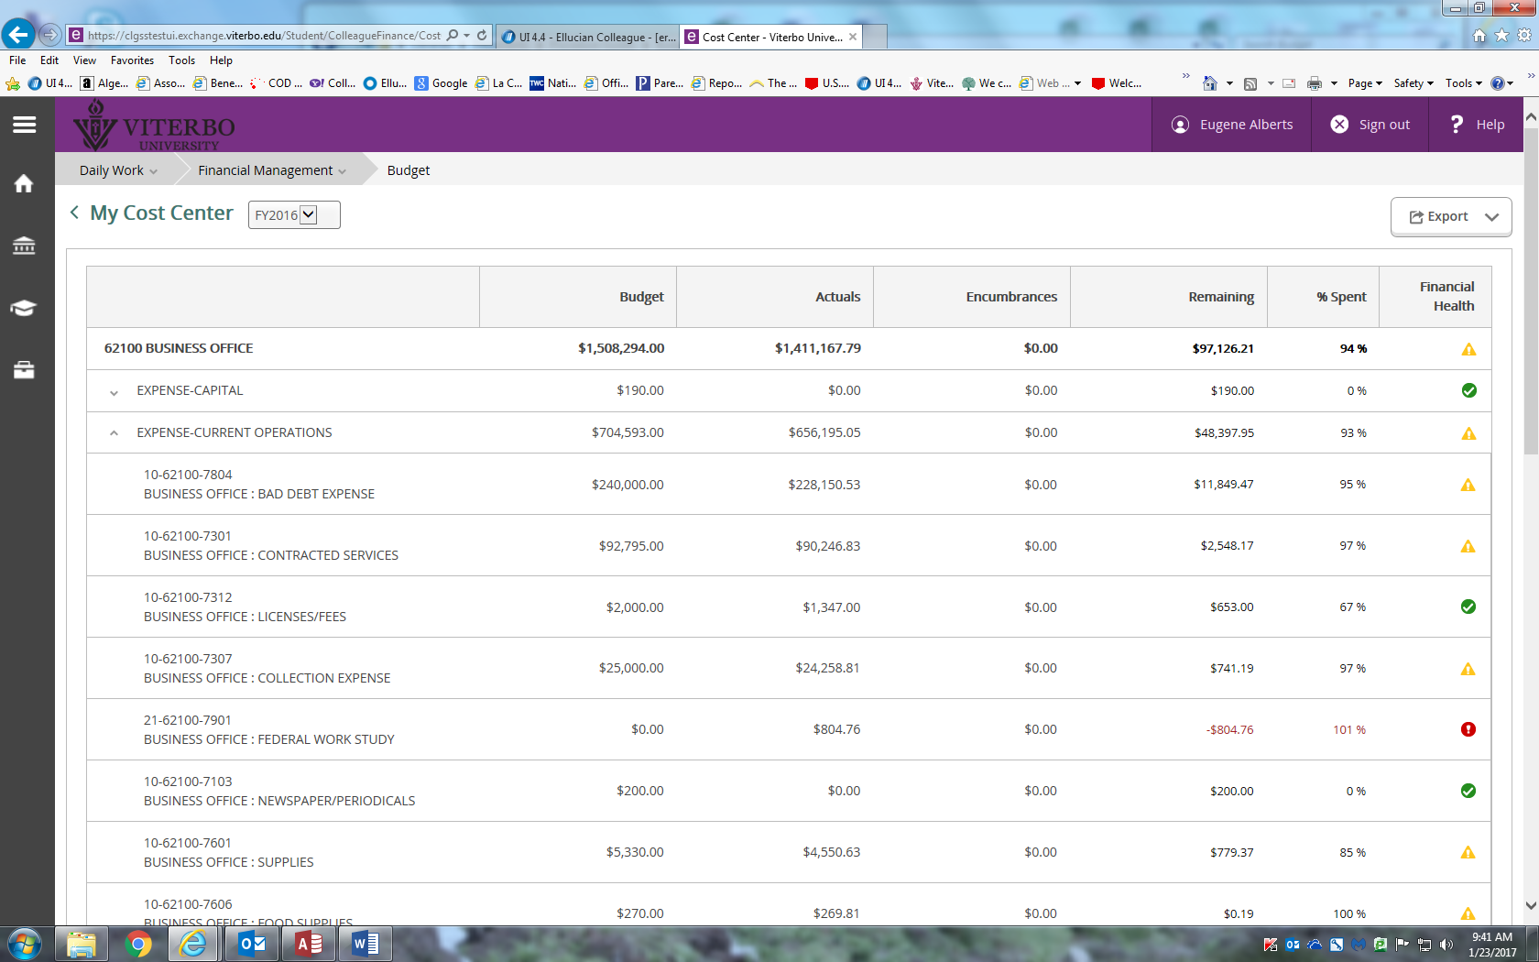
For more detail keep on clicking
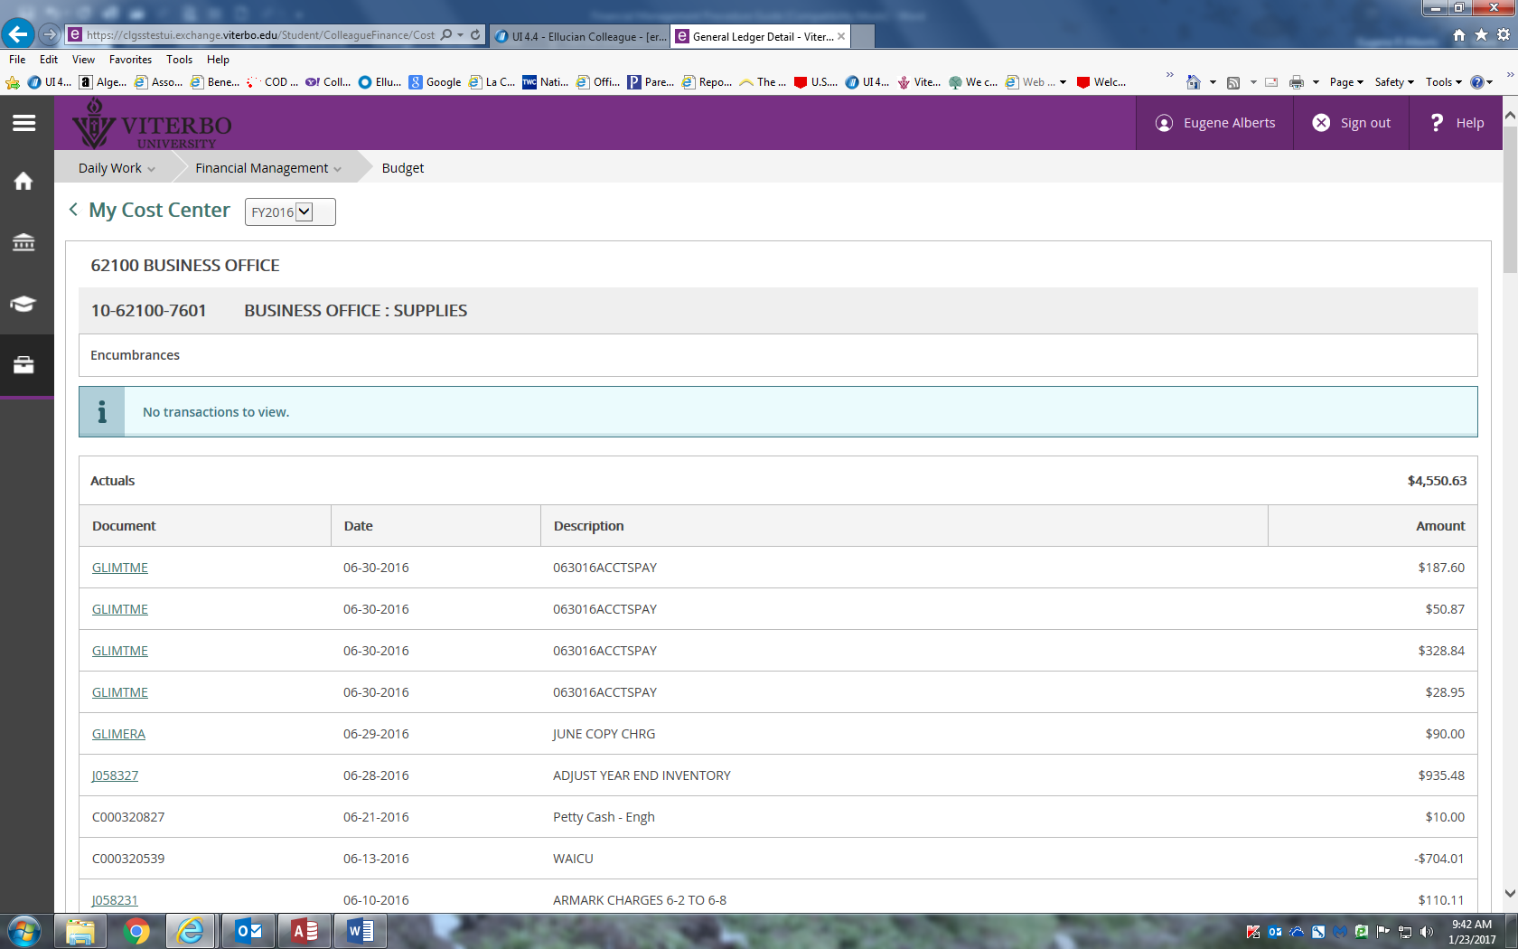
Click for more detail
You may look at up to five previous years by selecting the Fiscal button next to the Export function.
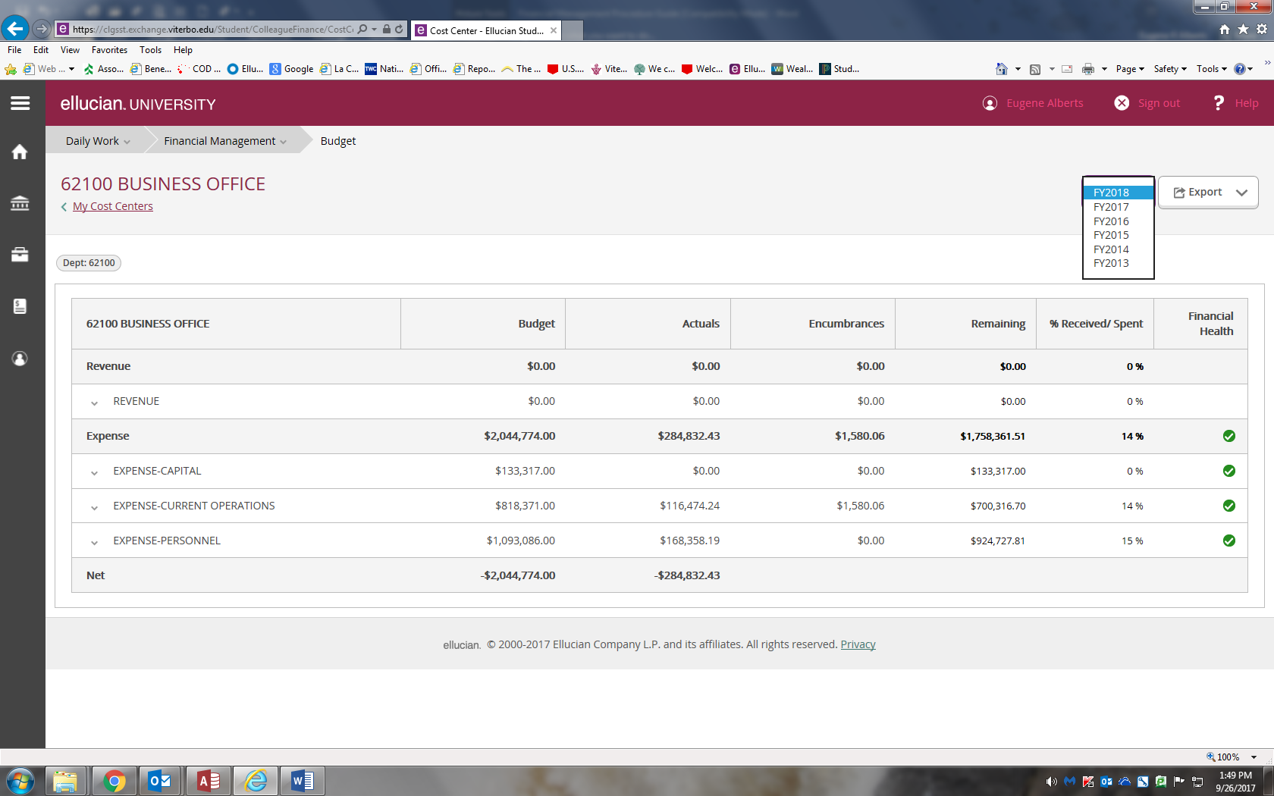
Select Year
You may also export information into Excel by selecting the Export Button located on the upper right side of the screen.

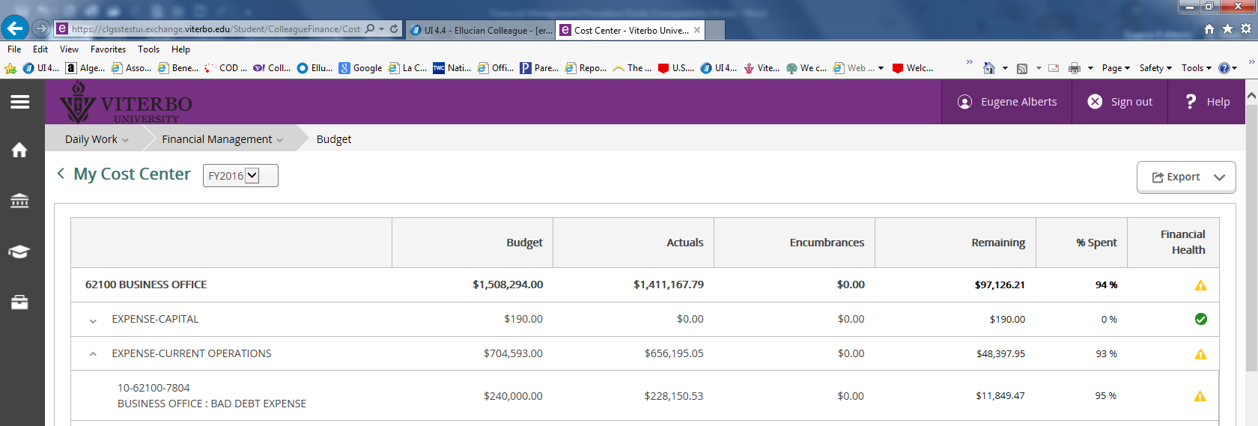
Export files to Excel

To go back use the back button at the upper left on side of your screen

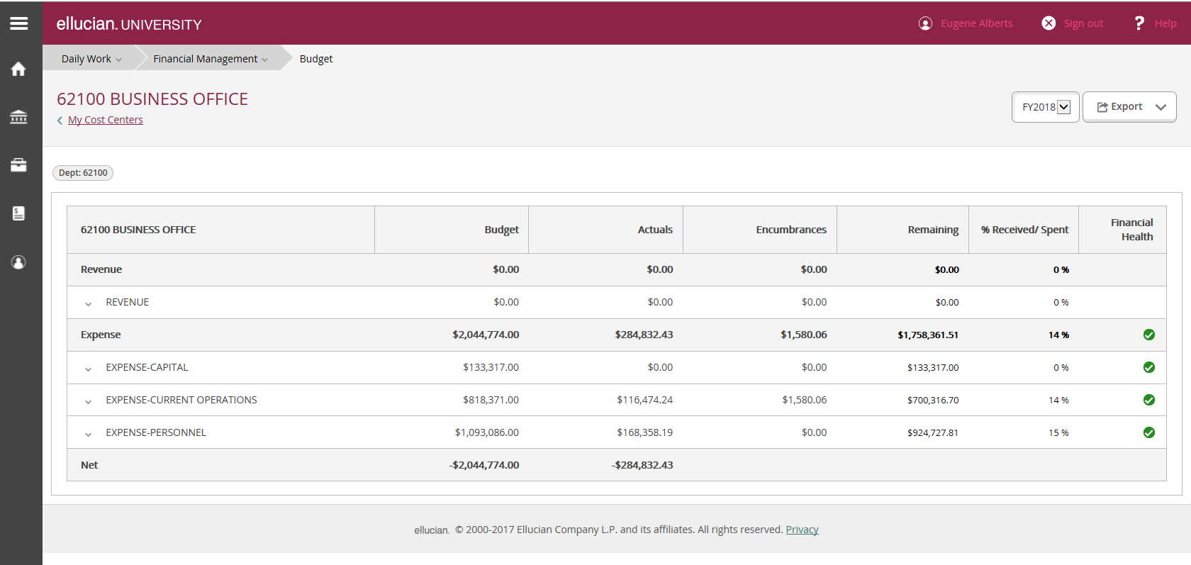
Use back button

