Logging into TracDat

- Logging in to TracDat.
  - Open the preferred website browser Firefox.
  - The link to TracDat can be found in MyVU: http://www.viterbo.edu/myvu
  - Click the TracDat option.
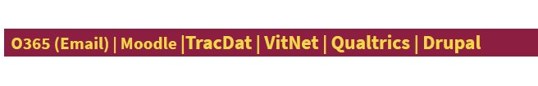
  - Username and Password: Your username and password is the same as your
Viterbo University username and password. NOTE: Do not include the @viterbo.edu portion of your username/email.

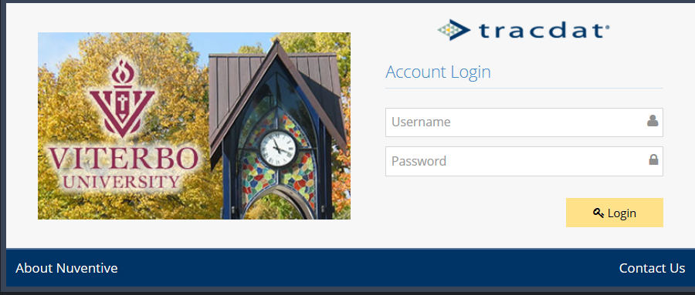

  - When you first go into TracDat, the unit that you were using the last time you logged out, should be the unit that is initially loaded. If not, select the correct unit that you wish to work with from the drop-down list. Units are named with the School’s initials and then Program Name. Example: COBAL: Marketing

- The first screen displayed is the Home screen with the Assessment Unit Planning Summary. This shows your Unit’s Outcomes and the number of their Assessment Methods, Results, Actions and Follow-Ups for that unit.
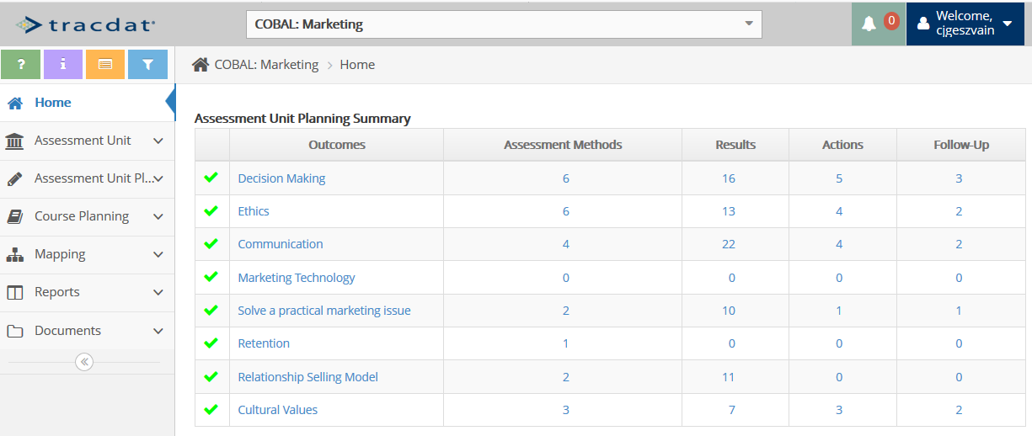

- Notice that each of the numbered items is a quick link to that Outcome’s specific area. Example, if you click the 22 (Communication – Results), you will go to the Results screen for the Communication outcome.
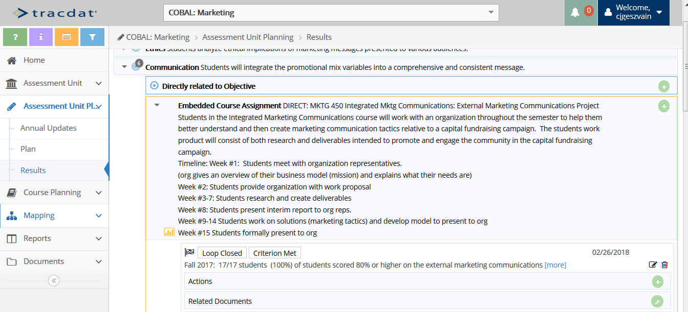

If questions on TracDat, contact the Assessment & Institutional Research department:
Carol Geszvain, Ext. 3485, cjgeszvain@viterbo.edu
Derek Klein, Ext. 3486, dpklein@viterbo.edu
Naomi Stennes-Spidahl, Ext. 3481, nrstennesspidahl@viterbo.edu

