Evacuation Assembly Areas
Evacuating from Residential Buildings (La Verna, Treacy, Clare, Canticle, Rose, McDonald, Bonaventure, Student Union, Marian): Assemble in Lot Q across from the Physical Plant
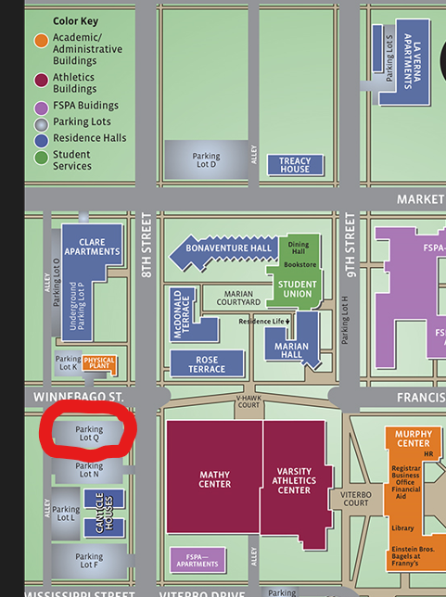
Evacuating from Academic Buildings (Murphy, Sister Thea Bowman, San Damiano Chapel, Brophy/Dahl School of Business, School of Nursing, Fine Arts Center, Reinhart, Varsity Athletic Center, Mathy Center): Assemble in Assisi Courtyard
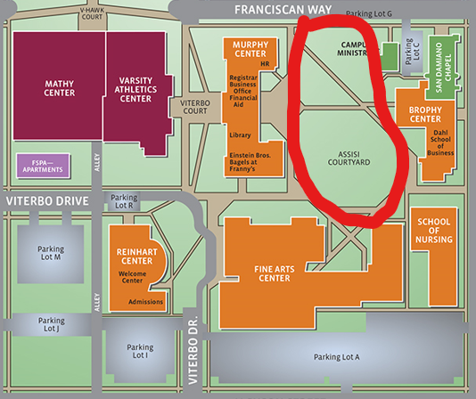
In case of inclement weather, alternate meeting area is the Mathy Center. Staff will be available to let you in.

