How to Run the Standard Report in TracDat
TracDat Version 5, 05/17/2018
- Select the desired Unit from the drop down at the top of the screen.
- Click the ‘Reports’ tab from the left-hand navigation pane.
- Click the ‘Standard Reports’ sub-tab.
- You will see the ‘Assessment Unit Four Column’ report listed under the Assessment Unit Reports section.

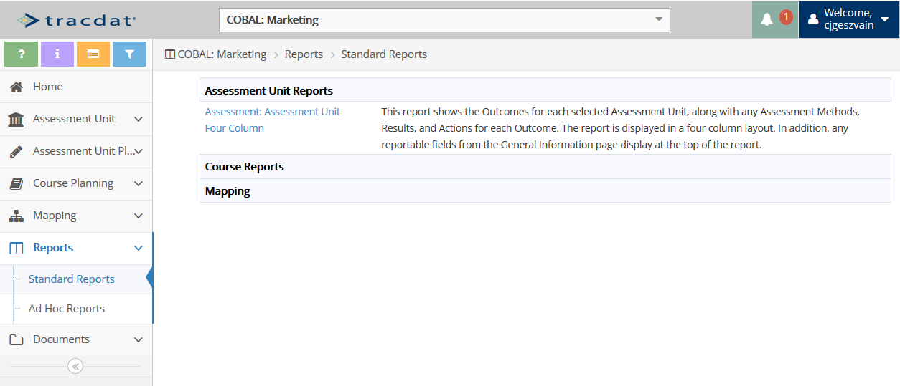

- Click on the ‘Assessment: Assessment Unit Four Column’ report name.

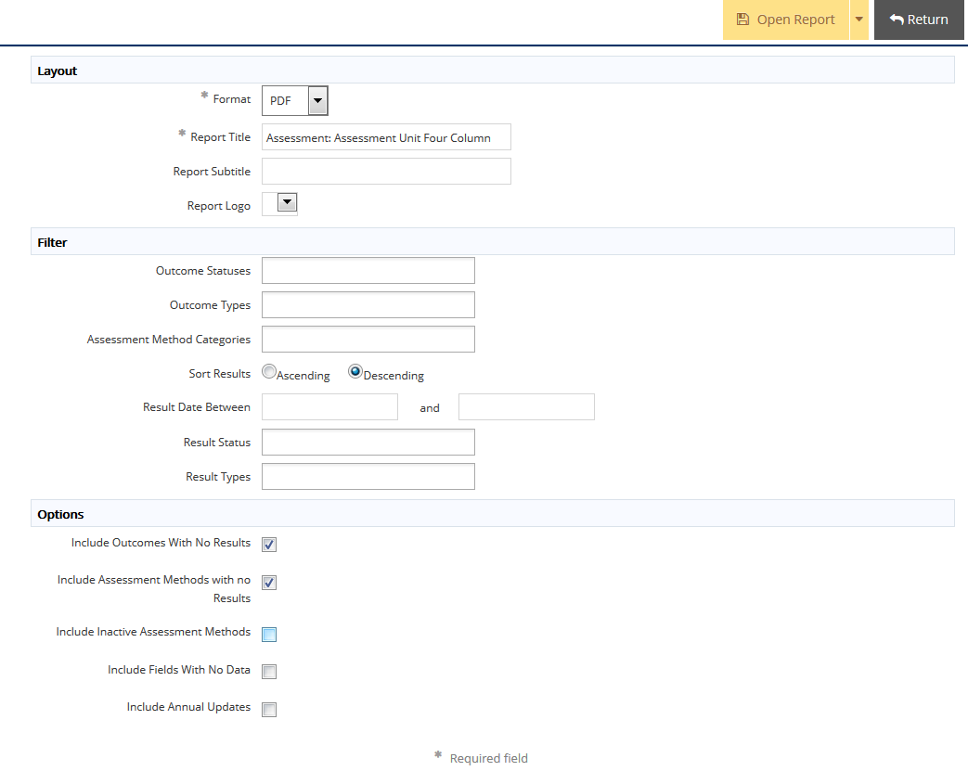

Layout

- Choose the format for your report. PDF, HTML or WORD are the most common formats. HTML is best for web-viewing.
- Enter a title for your report. NOTE that “Assessment: Assessment Unit Four Column” is entered as a default title, but you can click in the text box and replace that with a more specific name.
- Enter an optional subtitle.
- Report Logo: This option is not available at this time.

Filter. Decide if you want to apply filters. You can choose to filter data such as active or inactive outcomes, specific assessment years, and assessment method categories, etc.
- Outcome Statuses: Active, Complete, Discontinued, Inactive
- Outcome Types: Administrative, Learning, Standards, Strategic. Most of our outcomes are learning outcomes.
- Assessment Method Categories: Artistic Performance, Capstone Assignment/Project, Embedded Course Assignment, Embedded Exam Question(s), Enrollment, Field Placement/Clinical/Practicum, Internship/Research Experience, Participation, Portfolio, Standardized Test, Student Teaching Experience, Survey
- Sort Results: Ascending (oldest to newest), Descending (newest to oldest)
- Result Date Between: Click in the text boxes to enter specific dates.
- Result Status: Loop Closed or Pending Follow-Up
- Result Types: Criterion Met or Criterion Not Met

Options. Choose additional options to include in the report.
- Include Outcomes With No Results.
- Include Assessment Methods With No Results
- Include Inactive Assessment Methods
- Include Fields With No Data
- Include Annual Updates

- Click either: ‘Open Report’ to view in a new tab; ‘Download as Zip’ to save to your computer; or ‘Save to Document Repository’ to save to any of your report folders.
If you selected the Word format, you may see an additional prompt to Open with Word, or Save File. Select one of the options and click OK.

If questions on TracDat, contact the Assessment & Institutional Research department:
Carol Geszvain, Ext. 3485, cjgeszvain@viterbo.edu
Derek Klein, Ext. 3486, dpklein@viterbo.edu
Naomi Stennes-Spidahl, Ext. 3481, nrstennesspidahl@viterbo.edu

