How to Create a Student Learning Outcome in TracDat
In this example, I am using the Engineering unit in TracDat.

- Login to TracDat and select the unit you wish to work in from the top menu
(COESM: Engineering). Item A in picture below.

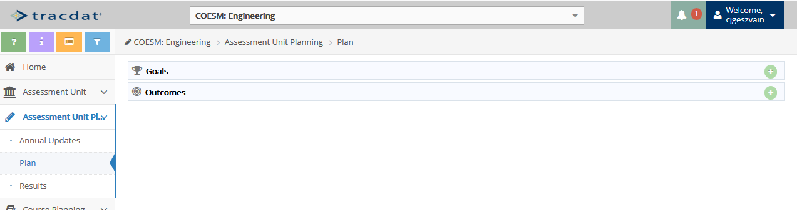
D
C
B
A

- Click on the left-side menu item: Assessment Unit Planning – Item B in picture above.
- Then click on the left-side menu item: Plan – Item C in picture above.
- To create a new Outcome, click the green plus sign on the Outcomes line item – Item D in picture above. This will open the Add Outcome screen as shown in the picture below.
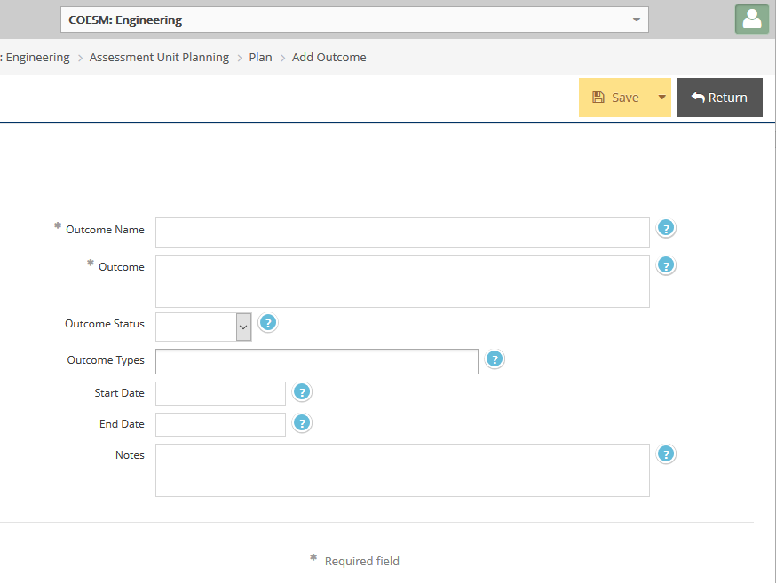

Fill in the following fields at a minimum. Fields with an * are required:
Outcome Name
Outcome (description)
Outcome Status: Options are: Active, Complete, Discontinued, Inactive
Outcome Types: Options are: Administrative, Learning, Standards and Strategic
Start Date: Once you click in this field, a calendar pops up to select a date. The current date is fine, or you can enter whatever date you feel appropriate.
- After entering the Outcome information, click the yellow Save button; then click the Return button. (Or you can click the yellow down arrow next to the Save button, to select the
Save and Return option.)

Example of Outcome…
- An Outcome call “Problem Solving” from the Mathematical Physics unit is shown:
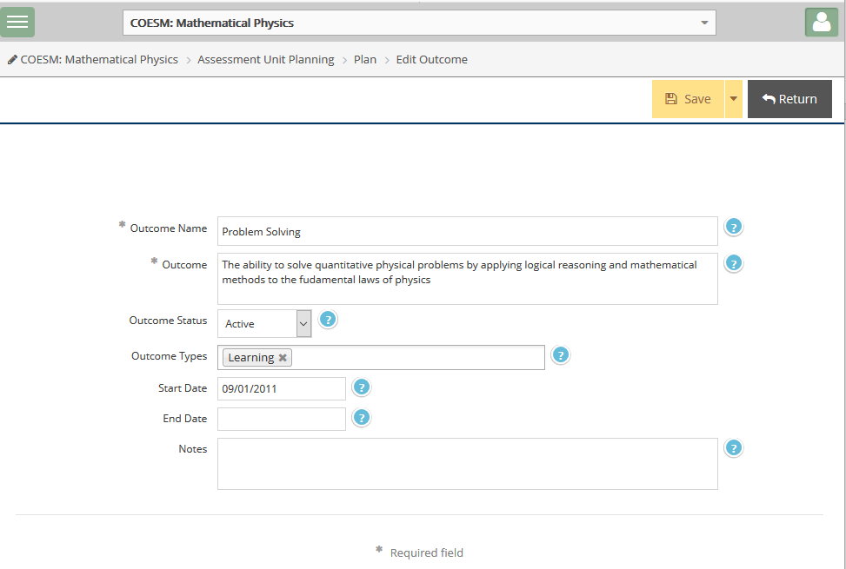

After clicking Save and Return, you go back to the Assessment Unit Planning > Plan
screen as shown below.

Here is the “Problem Solving” Outcome as shown in the Assessment Unit Planning > Plan screen:

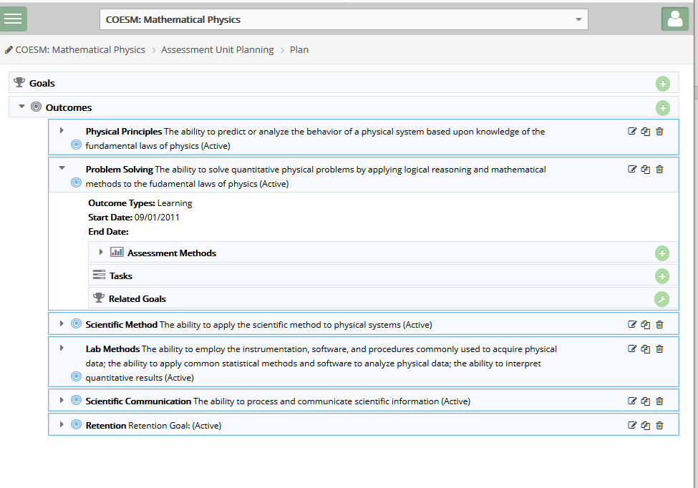

- This Outcome doesn’t have any Assessment Methods assigned yet.

- To add an Assessment Method, do so from this screen, by clicking the green plus sign on the Assessment Methods line item (circled above). The following screen will appear:
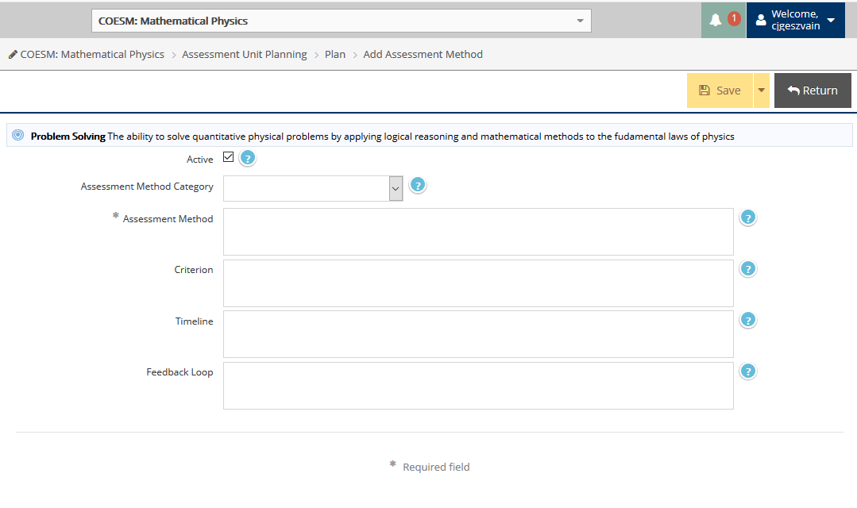
Fill in the necessary information and click the Save and Return buttons.
For more information on creating the Assessment Method, see document named
How to Add Assessment Method in TracDat.

If questions, feel free to contact the following Assessment & Institutional Research team members:
Carol Geszvain, Ext 3485; Derek Klein, Ext 3486; or Naomi Stennes-Spidahl, Ext 3481.

