How to add a New Assessment Method in TracDat
In this example, I am using the Religious Studies unit, and will show how to add a new Assessment Method to
Outcome # 3.1.

- Login to TracDat and select the unit you wish to work in from the top menu
(COAL: Religious Studies)

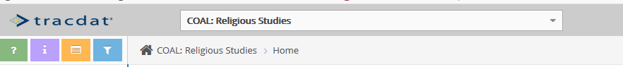

- From the Home screen, a quick way to get to the right place, is to click on the Assessment Methods number (3), for Outcome 3.1: The Franciscan Tradition.

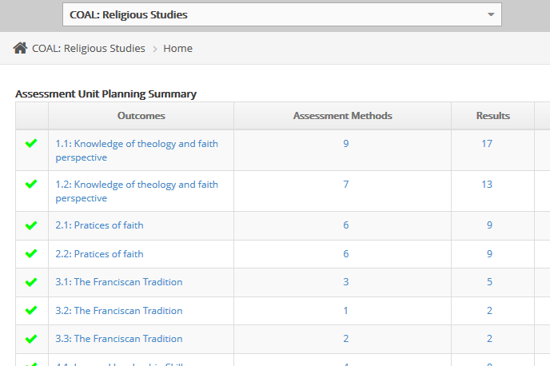

- A) Another way to get to the right place, is to click on the ‘Assessment Unit Planning’ tab from the Left-Hand Navigation pane.
B) Then click on the ‘Plan’ sub-tab
(see screen images A and B below).

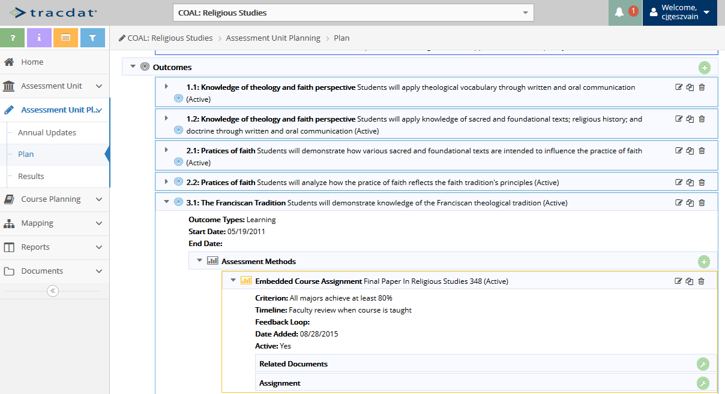
D
C
B
A

C) Then click the down-arrow to expand Outcome # 3.1: The Franciscan Tradition.
D) Click the Green Plus sign on the Assessment Methods title bar to create the new Assessment Method.
- The following screen should appear to fill in your Assessment Method information.
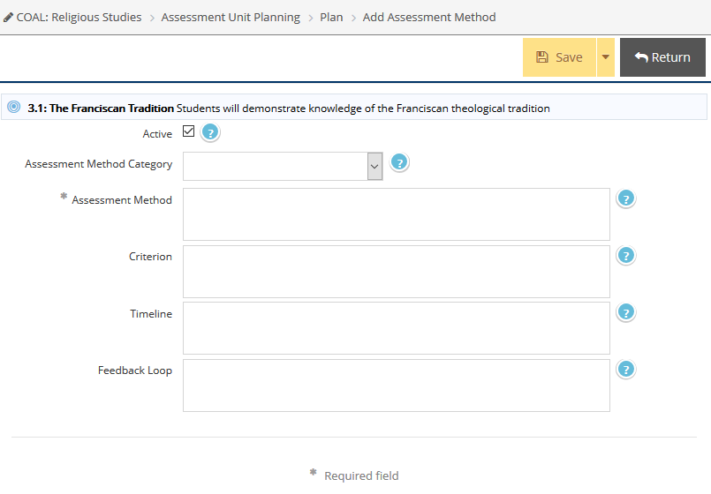
- Fill in the necessary information. Notice the only required field is the *Assessment Method field, but often more information is better than not enough. When done filling in the information, click the yellow Save button and then click Return to go back to the Assessment Unit Planning Area. (You can also click the yellow down-arrow next to the Save button, to see the command Save and Return.)

- This new Assessment Method should now be ready to add a result to.

If questions, feel free to contact the following Assessment & Institutional Research team members:
Carol Geszvain, Ext 3485; Derek Klein, Ext 3486; or Naomi Stennes-Spidahl, Ext 3481.

